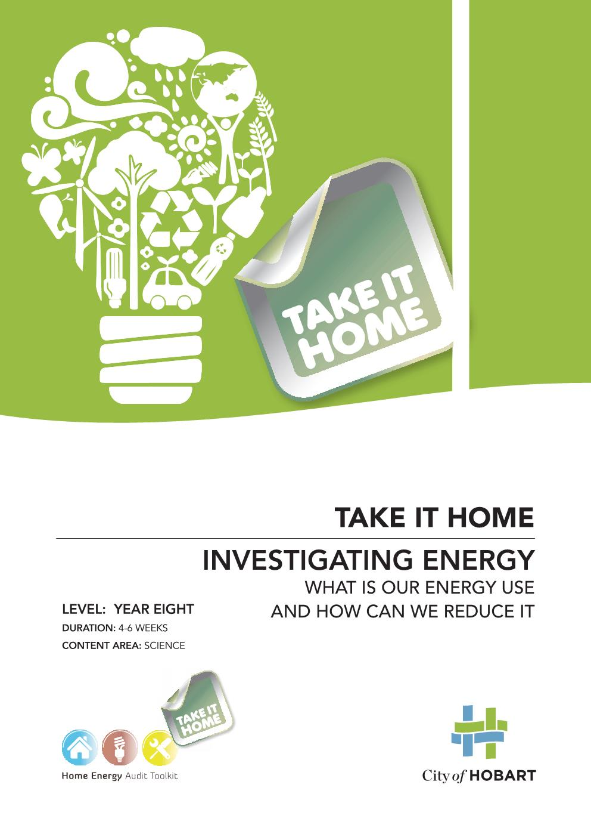
Content
Introduction 3
Year Eight Australian Curriculum links 4
Take it Home Program Outline 5
Activity 1. Golf ball experiment – does a golf ball have energy? 8
Activity 2. Energy transfer experiment 9
Activity 3. Conservation and transformation of energy experiment 11
Activity 4. Insulation experiment 12
Activity 5. Heat 13
Activity 6. Home energy audit toolkit (equipment investigations) 17
Activity 7. What appliances use electricity in your home? 18
Activity 8. How much does it cost to run your household appliances? 19
Activity 9. Appliance investigations 20
Activity 10. Standby investigations 21
Activity 11. Investigating star ratings 23
Activity 12. Investigating light globes 25
Activity 13. Heat loss and gain in a house 27

Introduction
‘Take it Home – secondary’ is a series of activities designed to help Year Eight students develop an awareness of energy consumption in the home and at school.
Through a range of hands-on activities, students learn how energy is used and look for clues on how it is being wasted, then plan and take action in practical ways to save energy. Students audit their classroom, school and home energy use using the HEAT toolkit and the activities in this document. Students then develop action plans to reduce their energy use with the support of members of the school community, scientists and other partners.
The Take it Home secondary program aligns with the Year Eight Australian Curriculum and embeds learning about sustainable lifestyles, energy efficiency and the reduction of greenhouse gases.
The City of Hobart collaborated with New Town High School to develop these teaching materials for secondary students and with the Snug Primary School to develop primary school materials. The City has now brought the two projects together to create a resource that can be used by schools across southern Tasmania.
The activities are based on the City of Hobart’s ‘Home Energy Audit Toolkit,’ which can be borrowed at no cost from the City of Hobart in class sets.
The program resources and materials are hosted on the City of Hobart website: http://www.hobartcity.com.au/Environment/Home_Energy_Audit_Toolkit_HEAT.
The ‘Take it Home’ secondary program develops the following skills:
- generating hypothesis
- gathering and analysing data
- applying science knowledge and understanding to real world situations
- report writing

Year Eight Australian Curriculum links
Science Understanding | Science as a Human Endeavour | Science Inquiry Skills
Energy appears in different forms, including movement (kinetic energy), heat and potential energy, and energy transformations and transfers cause change within systems (ACSSU155) | Solutions to contemporary issues that are found using science and technology, may impact on other areas of society and may involve ethical considerations (ACSHE135) | Identify questions and problems that can be investigated scientifically and make predictions based on scientific knowledge (ACSIS139)
recognising that potential energy is stored energy, such as gravitational, chemical and elastic energy (ACSSU155) | Science knowledge can develop through collaboration across the disciplines of science and the contributions of people from a range of cultures (ACSHE226) | Construct and use a range of representations, including graphs, keys and models to represent and analyse patterns or relationships, including using digital technologies as appropriate (ACSIS144)
investigating different forms of energy in terms of the effects they cause, such as gravitational potential causing objects to fall and heat energy transferred between materials that have a different temperature (ACSSU155) | People use science understanding and skills in their occupations and these have influenced the development of practices in areas of human activity (ACSHE136) | Summarise data, from students’ own investigations and secondary sources, and use scientific understanding to identify relationships and draw conclusions based on evidence (ACSIS145)

Take it Home Program Outline
Activity | Time | Content | Overview | Activities
- Golf ball experiment | 1 hour lesson  Links and report outline provided | Potential and kinetic energy  Law of Conservation of Energy | What is energy and what are some different forms of energy?  - Develop a working definition for the concept/term energy based on observation of the world around them.  - Identify and differentiate between types of energy (potential, kinetic, heat, chemical, mechanical, magnetic).  - ‘Energy’ and ‘power’ including units of measurement of electricity. | - Whole class focus: students brainstorm ideas around energy (food for our bodies, energy use at school and at home etc).  - Golf ball energy experiment  - Revisit their original energy brainstorm ideas and categorise these ideas according to whether they are examples of heat, chemical, potential, kinetic, magnetic or mechanical energy (remind students that some things will fit into more than one category and that they will need to suggest why).  - In small groups – students are given a selection of objects. Students to describe what kind of energy each has (objects might include wind-up toy, rubber band, tennis ball, spinning top, etc.).
- Energy transfer experiment (Rubber band car) | 3 x 1 hour lesson  Links and report outline provided | Elastic and kinetic energy  Student lead inquiry | What is energy and how is it transferred?  - Understand the concept of energy transfer.  - Understand the concept of efficiency. | - Simple experiments to explore energy transfer- see Rubber Band Car Experiment
- Bouncing ball experiment |  |  | What is the connection between energy and electricity?  How can we represent energy transfer?  - Connect energy transfer to the production of electricity.  - Identify and label a system of energy transfer.  - Understand the law of conservation of energy (i.e. energy cannot be created or destroyed - It can only be transferred from one state to another). | - Use the specific example of hydro electricity to explore connection between energy and electricity.  - Draw and label a flowchart or diagram that describes the energy forms and changes that occur as water is released from dams and runs into power stations. Students could then draw flowcharts for other energy transfer processes around them (i.e. boiling kettle, running the car).  - Discuss/investigate why Hydro Tasmania is currently replacing old pipes with new pipes containing turbines (potential energy previously unused now being put to better use).  - Bouncing ball experiment
- Insulation experiment (hot drinks) | 1x hour lesson  Worksheet provided | Conduction, heat transfer, particle theory | What is heat?  What role does heat have in energy transfer and electricity production?  - Identify the sun as the source of nearly all our energy.  - Identify convection, conduction, radiation, absorption and reflection as important components of heat.  Understand conversion of electrical energy to heat and what efficiency losses are. E.g. Incandescent and cfl globes. | - Investigate heat – ways in which different materials gain and lose heat energy. How does the type of cup used affect the cooling rate of a hot drink?  - Heat experiments – wax rings and metals, different colours and absorption
- Expansion of solids, liquids and gases when heated
- Introduction of the HEAT kit | 1 x hour lesson  Take home homework | Use of scientific equipment | How can we use the HEAT to measure energy use?  How can we conserve energy?  - Investigate and evaluate energy use in the home.  - Report upon different household uses of energy.  - Look for ways to create more efficient energy use in the home. | - In groups - each group to receive one object from the toolkit (compass, powermate, etc) and, using the worksheet provided, identify this object, its use and how it might help to improve energy efficiency at home.  - Plan and organise an activity based upon conducting an energy survey of a section of the school.  - Conduct a survey of electrical appliances they use at home. Make estimations of how much power these things use – then use the powermate to complete the survey.  - Appliance investigation – Consider the question: Are there ways of improving the use and efficiency of appliances in your home?  - Investigate the power use of appliances on ‘standby’ mode.
- Electricity usage of common appliances  - The cost to run appliances  - Appliance investigations  - Standby investigations | 2 x 1 hour lessons  Worksheet provided  2 x 1 hour lessons  Table, info and extension task | Analysing data, electricity conversations, voltage vs. current, energy efficiency of appliances  Using scientific formulas
- Investigating star ratings |  |  | How and why does the way we live impact on energy consumption?  - Connect technological advances to greater energy efficiency.  - Understand how heat is gained and lost in a house.  - Research, explore and document the different design elements of housing and how this relates to energy efficiency. | - Test the accuracy of ‘star ratings’ on electrical appliances.  - Explore the advances and subsequent efficiencies in light bulb technology.  - Heat loss and gain in a house activity.  - Research, write up and report on architectural design specific to its energy efficiency. For example, students could complete a SWOT analysis of their own home’s design and its subsequent efficiency.
- Investigating light globes | 1 x hour lesson  Links and worksheet provided | Using scientific formulas  Investigating new technologies
- Heat loss and gain in a house | 1 x hour lesson  Links and worksheet provided | Investigating energy transfer between natural and built environments.

- Golf ball experiment – does a golf ball have energy?

Aim: This experiment will help you to answer this question and to discover how energy can change form.
Equipment  - golf ball  - triangular piece of wood that can be marked (to be used as a ramp)  - protractor  - tape measure  - writing and marking pens  - paper to record your results | Method  - Create a ramp using a triangular block of wood. The slope should have a 15º angle.  You can use the protractor to check the angle.  - Mark the number of centimetres from the bottom of the slope to the top (i.e. 10cm, 20cm, 30cm, and 40cm).  - Place the golf ball at the 10cm mark on the slope and then release it (but do not push it).  - Measure the distance from the base of the slope to the point at which the golf ball came to a stop.  - Repeat this process from the different points marked on the slope. Record your results.
Results
Graph your results (the horizontal axis should show the distance travelled and the vertical axis should show the point of release). Ensure your graph has a title, measurement units and that you have labeled each axis
Discussion
What patterns did you see? Where did the golf ball have potential energy and kinetic energy?

Extension activity
Vary this experiment by using different round objects (tennis balls, ball bearings, etc.) and recording how far these objects travel from the slope; or you could change the angle of the slope. What difference does a 45º angle make?

- Energy transfer experiment
Various videos and sites on the internet show how to create a rubber band powered car, boat or airplane. Students can look at these to decide the best example of a rubber band powered machine. Once the students have decided upon a design they need to get approval from their classroom teacher before proceeding.
The students can be given the assessment rubric before beginning the task so the expectations are clearly outlined. The task can be assessed on the design of the project as well as the completed written report.
The report should contain a diagrammatic plan for the project, accompanied by a step by step method; an explanation of the changes in energy forms using scientific language referring to the law of conservation of energy; and a discussion which reflects upon your results and refers to the variables and possible future improvements.



Some online resources you may wish to use are:
PBS Kids Design Squad Nation: pbskids.org/designsquad/parentseducators/resources/rubber_band_car.html
You Tube – Rubber Band Car:
youtube.com/watch?v=A8nF31S6RmY&feature=player_embedded#at=103
Alternatively, the following Powerhouse Museum website has three different activities that explore energy transfer. See Activity 6 - Returning Tin Can, Activity 7 - Make Your Own Powerboat, Activity 8 – Car Launcher.
www.powerhousemuseum.com/pdf/education/toys_science_activities.pdf

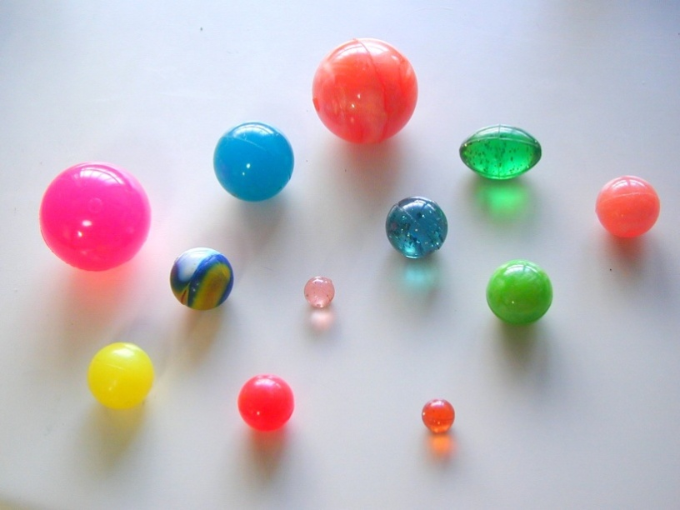

- Conservation and transformation of energy experiment
Teaching points
Students should have a background in the different forms that energy can take. They have hopefully realised that energy can exist in more than one form (for e.g. food has potential energy in the form of chemical energy).
The Law of Conservation of Energy states that energy is neither created nor destroyed, it just transforms from one type to another. As well as the more easily measurable energy forms, there are light and sound energy as well. As energy is not created or destroyed the amount of energy in the universe must remain the same. This can be easily highlighted in a simple experiment using a ‘super ball’, ‘bouncy ball’, or any other type of ball.
Transformation of energy experiment
Aim: To observe the transformation of energy from one form to another and see how this relates to the conservation of energy.
Equipment  - bouncy ball (or variety of balls)  - measuring tape, adhesive tape or ‘Tac’  - stop watch  - recording materials | Method  - Set up the measuring tape using tape or ‘Tac’ on a wall or other fixed structure. Hold the ball at a particular height and let it drop.  - Record your observations.  - Repeat this process and measure how high the ball bounces the first two times. Repeat these steps four times and record the results in a table
Discussion / Questions
- At what height did the ball have the greatest potential energy?
- At what height did the ball have the greatest kinetic energy?
- When does the potential energy of the ball begin to change into kinetic energy?
- When does the kinetic energy change into potential energy?
- Why does the ball lose height each bounce?
- Where does the extra energy go? (Conservation of energy says that the energy is not destroyed so it must have changed its form.)

Extension activity
Efficiency can be used to describe how much energy is lost in a process. The more efficient a process, the more energy that is retained and less lost. Try the above activity using different balls. Which was more efficient? Did the less efficient balls have louder noise levels or other forms of energy loss?

- Insulation experiment
If you want to keep your hot drink warm for as long as possible, what kind of material is the best insulator?
Design an experiment to test the insulation properties of three different kinds of cups: plastic, polystyrene and waxed paper.
Answer the following questions in order to plan and conduct the experiment.
- What equipment will you need to conduct the experiment?
- Why would you need a thermometer and stopwatch?
- How will you make the experiment a fair test?
- How will you record your results?
Making predictions:
Which cup do you think will be the best insulator? Explain why you think this will be the case, referring to energy transfer.
Extension activity
What difference would it make to have a lid on the cups?
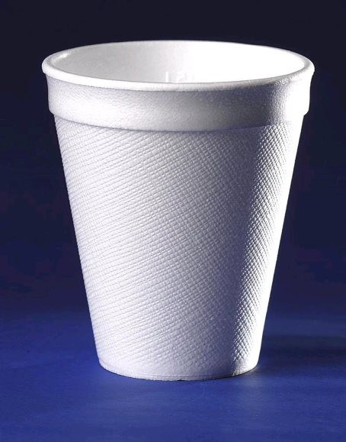

- Heat
The Expansion of solids
BALL AND RING | ROD AND GAUGE
Equipment:  - Bunsen Burner, heat proof mat  - Ball and ring apparatus  Method:  - Examine the workings of the ball and ring  - Heat the ball for a few minutes  - See if the ball will still fit through the ring  - Allow the ball to cool and try again  - Describe your observations | Equipment:  - Bunsen Burner, heat proof mat  - Rod and gauge apparatus  Method:  - Check length and diameter of the rod with the gauge  - Heat the rod for a few minutes  - See if the rod will still fit in the gauge  - Allow the rod to cool and try again
Hypothesis: | Hypothesis:
Observations: | Observations:
Aim:
To investigate the expansion of solids when heated
Conclusions:
Discussions:

BIMETALLIC STRIP
Aim: To investigate if different solids expand the same amount
Equipment:  Bimetallic strip  Bunsen Burner, heat mat | Method:  Heat the bimetallic strip evenly  Describe your observations  Allow the strip to cool
Comment
The Bimetallic strip is two different metals riveted together along its length. The metals are probably iron and brass.
Observations
Conclusions:
Discussions:
THE EXPANSION OF LIQUIDS
Aim: To investigate the expansion of liquids when heated
Equipment:  Flask  Water  Food colouring  Stopper and Glass tubing  Bunsen Burner, heat proof mat  Tripod, gauze mat | Method:  Fill the flask with water, add food colouring  Place the stopper and tubing in the flask  Note the level of the water in the glass tubing  Place the flask on the tripod with gauze mat  Heat with the Bunsen burner (pay attention!)  Describe your observations  Remove flask from the heat and allow time to cool.  Stand in cold water
Describe your observations
Hypothesis:
Observations:
Conclusions:
Discussion
THE EXPANSION OF GASES
Aim: To investigate the expansion of gases when heated
Equipment:  Flask  Stopper and Glass tubing  Beaker  Water  Food colouring  Cold wet cloth | Method:  Fit stopper and glass tubing in a cold flask  Put some coloured water in the beaker  Put the end of the tubing in the beaker of water  Hold your hands around the bottom of the flask (to warm it)  Describe your observations  Place a cold wet cloth on the flask  Describe your observations
Observations:
Conclusions:
Discussion:

If you have time, you can try putting a balloon over the top of a flask and heating
it (gently) on the Bunsen Burner

- Home energy audit toolkit (equipment investigations)
Examine your piece of equipment from the HEAT tool kit to decide what its function is.
What do you think this piece of equipment is used for? How would it help you to make your home more energy efficient?
Brainstorm a list below of all the possible uses you can come up with for this piece of equipment.
Name of object:
What are the possible uses? | How could this help increase energy efficiency in the home?

- What appliances use electricity in your home?

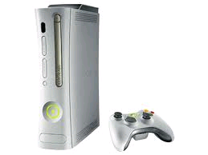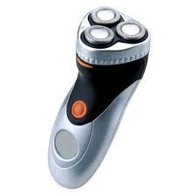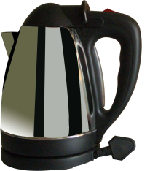
Create a list of all the things in your home that use electricity and make an estimate as to how often this appliance is used, and how much you think it costs to run. Then rank the appliances from most expensive to least expensive, per week of usage. There are a few examples listed to get you started – but alter them if they do not apply to your home.
Name of appliance | How regularly do you use this appliance? | How much does running this appliance cost? (estimate only) | Rank the appliances from most to least expensive
Toaster | Every morning
Rice cooker | Once a week
Refrigerator | Runs constantly
- How much does it cost to run your household appliances?
In the first part of this activity you made a list of all the appliances used in your family home. You also made estimates about how much money these appliances would cost to run (as well as ranking them in order from the most to the least expensive). Now, using the Powermate, you get to test out your hypotheses and see whether your ideas about your home’s energy consumption were on the money or not.

Appliance | Watts used per hour | Kilowatts used per hour  (A/1000) | Estimated hours used per day (if in minutes divide by 60) | Total kW used per day  (BxC) | Cost  per day (at $0.27dollars per kW)  (Dx0.27cents) | Cost per year  (Ex365)
 | A | B | C | D | E
Toaster 4 slice (used 10 minutes each day) | 1629 | 1.629 | 0.167hrs  (10mins) | 0.272kW | $0.07 (7 cents) | $25.75
Toaster 2 slice | 817
Spotlight (used 2 hours per day) | 176 |  | 2 hrs | 0.352 | $0.10 (10 cents) | $36.50
Hotplate
Kettle
Coffee maker (standby) | 0.45
Fan
Rice cooker

- Appliance investigations
Look around your house and take some time to think about your appliances. Look at the list you made previously and choose 5 appliances to examine more closely. Are there ways you could improve their use and efficiency and save your family some cash?
For example – is your fridge positioned next to your stove? Take note of how often the fridge runs when the stove is used for cooking.

Name of appliance:
Possible inefficiency | Possible solutions
Name of appliance:
Possible inefficiency | Possible solutions
Name of appliance:
Possible inefficiency | Possible solutions
Name of appliance:
Possible inefficiency | Possible solutions
Name of appliance:
Possible inefficiency | Possible solutions
- Standby investigations
Myth Buster
Electrical items on standby use up to 10% of total electricity costs. Is this true? Using the Power mate from the Home Energy Kit, test various electrical items at school and home which use standby mode. Often equipment on standby will be warm to the touch (or have a transformer that is warm) or have an indicator light (such as a camera charger) or a clock (such as a microwave or television).
Standby modes- active and passive (sleep) stand-by modes.
Most households use electricity even when no appliances are being used. This is called stand-by energy consumption and can amount to over 10% of total electricity used in a typical home.
Average standby annual costs
Appliance | Standby energy- watts | Annual cost
Television | 10 | $15
Microwave | 4 | $ 6
clock radio | 4 | $ 6
VCR | 8 | $ 11
mobile phone charger | 1 | $ 2
Computer | 5 | $ 8
Monitor | 5 | $ 8
Printer | 8 | $ 11
Television | 10 | $15

Using the information you collected from your previous monitoring of power usage in the home and school, fill in the table below with some of the important electrical appliances that are missed off the list. Add in any others you think should be there.
Appliance | Standby energy- watts | Annual cost
Gaming console
Mp3 player

Extension activity - Investigate your school
If there is that much power used in schools when computers and monitors are on standby, does your school have a way of minimising this?
Ask your teacher or I.T. department if they have taken steps to reduce this power usage and list the ways. If they haven’t, research how you could reduce the time that monitors and computers are on standby, and ask your teacher if you can pass on your recommendations to your Principal. Everyone wants to save money!

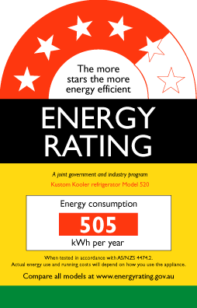
- Investigating star ratings
Choosing an energy efficient appliance is one way to reduce greenhouse gas emissions while saving money. The Energy Rating label helps compare the energy efficiency appliances at school and at home. It also provides incentive for manufacturers to improve the energy efficiency of appliances.
In Australia all new refrigerators, freezers, clothes washers, clothes dryers and dishwashers must carry an Energy Efficiency Label. It has two main features:
- Star rating – the more stars, the more energy efficient is the appliance.
- Energy Consumption – the lower the kilowatt per hour figure, the less energy the appliance will use.
- The star rating (1-6) of an appliance is worked out from the energy consumption and size of the product. Appliances must meet Australian Energy Standards for an Energy Rating Label.
http://www.energyrating.gov.au/sites/prod.energyrating/files/15-44830-Energy-Rating-Label-A4-flyer-PRESS-ART-01.pdf
Aim
Work out whether your ‘star rated’ appliances have the same efficiency as their labels suggest.
Activity
Using the information you collected from your home appliances (Activity 6) work out whether you ‘star rated’ appliances have the same efficiency as their labels suggest.
Why or why not do you think this is the case?

Extension activity
Take home a ‘Power Mate’ and undertake a two week survey of a star rated appliance. From this information calculate the power usage in kWh per year.
Is this the same as your previous answer?
Why/why not?
Why is it useful to monitor for two weeks?

This is an example of an energy rating showing the difference between warm and cold washing. Did you know that if a dishwasher heats its own water it is more efficient than one that uses water from a hot water cylinder?  With the person next to you discuss why this might be the case. | 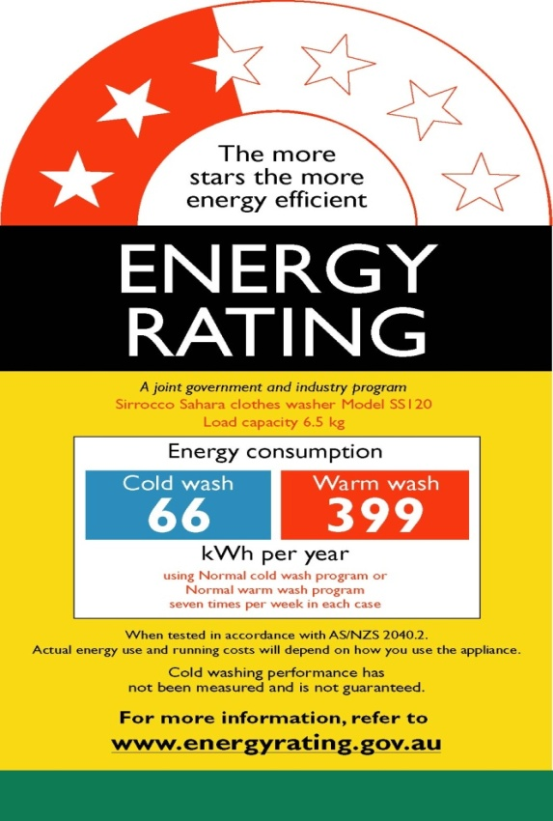

Investigating Water ratings
Water ratings are becoming more common on appliances. Above are a couple of examples of what a water rating may look like. Do you think that now we have metered water usage consumer pressure will lead to more ratings on appliances as it impacts upon how much money it costs households?
- Investigating light globes
Incandescent light globe bulb | Compact fluorescent light | Halogen lights | LED globes
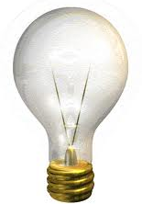 | 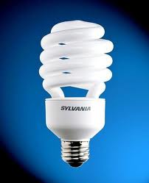 | 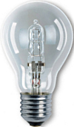 | 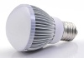
Which is the brightest idea?
Compact fluorescent light globes (CFLs) are an energy-saving alternative to old incandescent light globes. They use up to 80% less energy than old globes and last up to eight times longer.
Incandescent globes or Filament globes are being phased out. Energy saving light globes can save up to 66% of energy costs.
Light Globe Conversion Table
Watts are the measure of power, lumens are the intensity of light.
Incandescent bulbs | Compact fluorescent light (CFL) | Halogen lamp | Light output in lumens (lm) light intensity
25 watts | 5-7 watts | 18 watts | 220 lm
40 watts | 7-8 watts | 28 watts | 420 lm
60 watts | 11-12 watts | 42 watts | 720 lm
100 watts | 13-18 watts | 52 watts | 930 lm
Halogen light globes are also more efficient than incandescent globes but they get very hot and are a concern with ceiling insulation. Halogen light globes are often more numerous, so instead of having one or two incandescent or CFL globes, 8-10 ‘down lights’ are installed, which reduces the benefit of the reduced power usage.
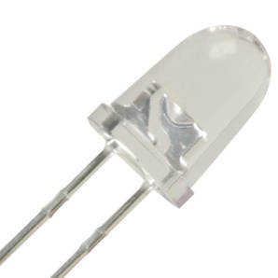 |  | 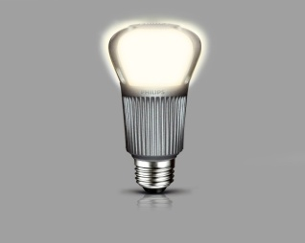

Light emitting diodes (LEDs) are the new kid on the block in lighting. With a life span of 30,000 hours compared to incandescent globes (1000hrs) and compact fluorescent lamps (8000hrs) they have a lot to live up to. A 13W LED has the equivalent power of a 100W incandescent globe and around 800 lumens! That is a big light source, for little power and long life.

Light energy audit
Aim: To make an estimation of the costs of lighting in your home for a year.
Method
Undertake an audit of all the lights in your house and fill in the table below. Use the ‘difference in energy’ column to compare the light sources used in your house with one of the others discussed
 | Power  usage  (Watts) | Power usage  (kWh)  (Watts/1000) | Average running time per week (hours) | Energy used per week (kWh)  (kWh x hours) | Cost per week ($)  (0.27x kWh) | Cost per year ($)  (Costs per week x 52) | Difference in energy usage/ cost
 |  |  |  |  |  |  | kWh | $
E.g. Halogen Bulb | 70 | 70/1000  0.07 | 21 | 0.07 x 21 = 1.47 | 0.27x1.47=  0.39 (39 cents) | 0.39X52  $20.28
- Heat loss and gain in a house
Aim
To investigate how heat is lost and gained in a house and consider ways to control heat loss and gain in a house.
Activity
Write how heat is lost on one side of the arrow, and gained on the other side of the arrow for each on the areas listed on the star
e.g.
loose roofing (drafts)
poor insulation (heat gained in the day)
poor insulation (heat loss in the night)
roof
walls
floor
windows
doors

Aim
To record ideas for controlling the heat loss and gain in a house.
Activity
Fill in this blue star responding to the identified heat loss and gain in the orange star, and record ideas for controlling the heat loss and gain in each area. See below for example for the ‘roof’ arm of the orange star.
e.g. Secure roof to reduce drafts
Insulate ceiling to reduce heat loss/gain

roof
walls
floor
windows
doors
Assessing Strands and Sub-strands | Developing | Consolidating | Extending
Science Understanding  - Energy appears in different forms, including movement (kinetic energy), heat and potential energy, and energy transformations and transfers cause change within systems (ACSSU155)  - Recognising that potential energy is stored energy, such as gravitational, chemical and elastic energy | Student demonstrates a limited ability to:  - explain energy transfer  - refer to the law of conservation of energy  - display knowledge of the different forms of energy | Student demonstrates a satisfactory ability to:  - explain energy transfer  - refer to the law of conservation of energy  - display knowledge of the different forms of energy | Student demonstrate a comprehensive ability to:  - explain energy transfer  - refer to the law of conservation of energy  - display knowledge of the different forms of energy
Science as a Human Endeavour  - Science knowledge can develop through collaboration across the disciplines of science and the contributions of people from a range of cultures (ACSHE226) | Student demonstrates a limited ability to:  - Relating knowledge from a variety of different Scientific fields, to real world applications  - Show how the scientific principles incorporated within the experiment relate to past and present real world developments  e.g. Use of rubber band on a plastic wheel and its relationship with tyres within modern automotives | Student demonstrates a satisfactory ability to:  - Relating knowledge from a variety of different Scientific fields, to real world applications  - Show how the scientific principles incorporated within the experiment relate to past and present real world developments  e.g. Use of rubber band on a plastic wheel and its relationship with tyres within modern automotives | Student demonstrate a comprehensive ability to:  - Relating knowledge from a variety of different Scientific fields, to real world applications  - Show how the scientific principles incorporated within the experiment relate to past and present real world developments  e.g. Use of rubber band on a plastic wheel and its relationship with tyres within modern automotives
Science Inquiry  Measure and control variables, select equipment appropriate to the task and collect data with accuracy (ACSIS141)  Communicate ideas, findings and evidence based solutions to problems using scientific language, and representations, using digital technologies as appropriate (ACSIS148) | Student demonstrates a limited ability to:  - Identify and controls variables  - Write and follow an appropriate method  - Set up equipment correctly  - Use equipment correctly  - Accurately record results  - Write in 3rd Person  - Include all sections of the report  - Write a Discussion that relates to the experimental results and theory.  - Discuss and write about future research.  - Complete task with extensive teacher guidance | Student demonstrates a satisfactory ability to:  - Identify and controls variables  - Write and follow an appropriate method  - Set up equipment correctly  - Use equipment correctly  - Accurately record results  - Write in 3rd Person  - to include all sections of the report  - To write a Discussion that relates to the experimental results and theory.  - Discuss write about future research.  - Complete task with some teacher input | Student demonstrate a comprehensive ability to:  - Identify and controls variables  - Write and follow an appropriate method  - Set up equipment correctly  - Use equipment correctly  - Accurately record results  - Write in 3rd Person  - to include all sections of the report  - To write a Discussion that relates to the experimental results and theory.  - Discuss write about future research.  - Reference all past and present investigations  - Complete task with minimal teacher input
Planning and Conducting  Collaboratively and individually plan and conduct a range of investigation types, including fieldwork and experiments, ensuring safety and ethical guidelines are followed (ACSIS140)  Measure and control variables, select equipment appropriate to the task and collect data with accuracy (ACSIS141) | Student demonstrates a limited ability to Plan and conduct an investigation except with extensive teacher input:  - State an Hypothesis  - Identify and control variables  - Write and follow an appropriate method  - Set up equipment correctly  - Use equipment correctly  - Keep a log book for extended investigations.  - Accurately record results  - Complete task except with extensive teacher input | Student demonstrates a satisfactory ability to: Plan and conduct an investigation with limited teacher input:  - Clearly state an Hypothesis  - Identify and control variables  - Write and follow an appropriate method  - Set up equipment correctly  - Use equipment correctly  - Keep a log book for extended investigations.  - Accurately record results  - Complete task with some teacher input | Student demonstrate a comprehensive ability to: Plan and conduct an investigation with minimal teacher input:  - Clearly state an Hypothesis  - Identify and control variables  - Write and follow an appropriate method  - Set up equipment correctly  - Use equipment correctly  - Keep a log book for extended investigations.  - Accurately record results.  - Complete task with minimal teacher input
Processing data and analytical skills.  Construct and use a range of representations, including graphs, keys and models to represent and analyse patterns or relationships in data using digital technologies as appropriate (ACSIS144)  Summarise data, from students’ own investigations and secondary sources, and use scientific understanding to identify relationships and draw conclusions based on evidence (ACSIS145) | Student demonstrates a limited ability to:  - Presentation of data in a logical and accurate manner.  - Correctly represents data using tables and graphs  - Use scientific language correctly.  - Identify relationships and draw a conclusion.  - Analyse data independently except with extensive teacher input | Student demonstrates a satisfactory ability to:  - Presentation of data in a logical and accurate manner.  - Correctly represents data using tables and graphs  - To use scientific language correctly.  - To identify relationships and draw a conclusions.  - Analyse data independently with some teacher input | Student demonstrates a comprehensive ability to:  - Presentation of data in a logical and accurate manner.  - Correctly represents data using tables and graphs  - Use scientific language correctly.  - Identify relationships and draw a conclusion.  - Analyse data independently with minimal teacher input
Evaluating  Reflect on scientific investigations including evaluating the quality of the data collected, and identifying improvements (ACSIS146)  Use scientific knowledge and findings from investigations to evaluate claims based on evidence (ACSIS234) | Student demonstrates a limited ability to: (and complete these tasks except with extensive teacher input)  - Discuss data collected.  - Research and reference appropriate theory.  - Discuss results in relation to theory.  - Discuss experimental errors  - Independently evaluate experimental results except with extensive teacher input | Student demonstrates a satisfactory ability to: (and complete these tasks with some teacher input)  - Discuss data collected.  - Research and reference appropriate theory.  - Discuss results in relation to theory.  - Discuss experimental errors  - Independently evaluate experimental results with limited teacher input | Student demonstrates a comprehensive ability to: (and is able to complete these tasks with minimal teacher input)  - Discuss data collected.  - Research and reference appropriate theory.  - Discuss results in relation to theory.  - Discuss experimental errors  - Independently evaluate experimental results  - Identify trends and suggest reasons for these
Communication  Communicate ideas, findings and evidence based solutions to problems using scientific language, and representations, using digital technologies as appropriate (ACSIS148) | Student demonstrates a limited ability to: (except with extensive teacher input)  - Write in 3rd Person  - Have a report containing all sections.  - Write a Discussion that relates to the experimental results and theory.  - Write a Conclusion that directly links to the Hypothesis.  - Write about future research.  - Independently prepare the report except with extensive teacher help | Student demonstrates a satisfactory ability to: (With some teacher input)  - Write in 3rd Person  - Have a report containing all sections.  - Write a Discussion that relates to the experimental results and theory.  - Write a Conclusion that directly links to the Hypothesis.  - Write about future research.  - Independently prepare a report with some teacher help  - Have some discussion of the limitations of the experimental design and suggest strategies for improvement | Student demonstrates a comprehensive ability to: (with minimal teacher input)  - Write in 3rd Person  - Have a report containing all sections.  - Write a Discussion that relates to the experimental results and theory.  - Write a Conclusion that directly links to the Hypothesis.  - Write about future research.  - Independently prepare a report using mature scientific language,  - Have scientifically valid discussion of the limitations of the experimental design and many suggestions for strategies for improvement

Document Image references:
Activity 1 Golf Ball: http://media.photobucket.com/user/taurrichio/media/clip_image001.jpg.html?filters[term]=golf%20ball&filters[primary]=images&filters[secondary]=videos&sort=1&o=5#!
Activity 2 Rubber band car: www.misterengineer.com
Activity 3 – conservation of energy image ref (http://upload.wikimedia.org/wikipedia/commons/b/b8/Colorful_Super_ball.jpg)
Activity 4 – insulation image (http://myzerowaste.com/wp-content/uploads/2008/08/polystyrene-cup.jpg)

