City of Hobart Micromobility (e-scooter) Trial

Evaluation report February 2023

City of Hobart Micromobility (e-scooter) Trial 2

Introduction About Findings Conclusion

Evaluation report 3

Introduction

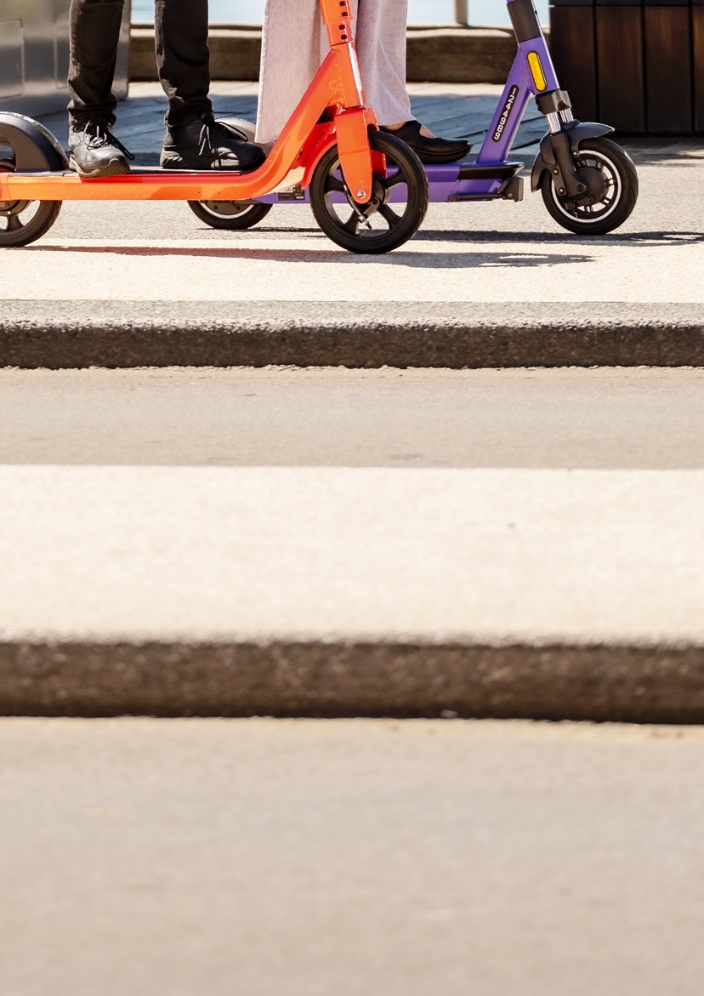
1

Introduction

Personal mobility devices
PMDs are small, electrically powered devices designed to transport one person over short to medium distances.
A device is a PMD if it is electrically powered and:
- has at least one wheel
- is less than 125cm long, 70cm wide and 135cm high
- is less than 45kg
- is not capable of travelling faster than 25 km/h
- is designed for use by one person.
The definition of a PMD aims to include a variety of micromobility technologies such as e-scooters, e-skateboards, self-balancing hoverboards and one-wheel devices.
Bicycles, motorised scooters, motorised wheelchairs, and wheeled recreational devices are not PMDs.
Tasmanian legislation
Legislation governing the use of Personal mobility devices (PMDs) was passed by the Tasmanian Parliament on 22 November 2021 via amendments to the Traffic Act 1925.
New rules for PMDs commenced on 1 December 2021 to allow PMDs on footpaths, shared paths, bicycle paths and some roads in Tasmania. Both privately owned PMDs and e-scooter hire-and-ride commercial services are covered by these rules.
A person must be 16 years or older to ride a PMD. Children under 16 will still be permitted to use low-powered e-scooters which do not exceed 200 watts and 10 km/h.

PMDs can be used on:
- footpaths
- shared paths
- bicycle paths
- local roads that have a speed limit of
50 km/h or less, no dividing lines or median strip, and only a single lane, if a one-way road.
Road managers, such as local councils, can identify additional roads with a speed limit of 50 km/h or less that PMDs can access. A list of these roads will be available on the relevant road manager’s website and in the Tasmanian Government Gazette if the road manager has declared any for PMDs to use.
PMDs cannot be ridden on a footpath where a ‘no personal mobility device’ sign has been installed.

City of Hobart Micromobility (e-scooter) Trial 6

PMD users must not exceed:
- 15 km/h on footpaths
- 25 km/h on shared paths, bicycle paths and roads.
PMD users must also ride with due care and attention, and with consideration for other road users. This means that even if users comply with the speed limits for PMDs, they may be liable for a fine if they are riding irresponsibly.

PMD users must:
- give way to pedestrians on footpaths and shared paths
- travel a sufficient distance from pedestrians in order to stop safely to avoid a collision
- keep to the left unless overtaking or where it is impracticable to do so
- ride with due care and attention
- ride with consideration for other road users.
PMD users must not use a mobile phone while riding a PMD and must not ride under the influence of alcohol or drugs.
Tasmania Police enforce road and traffic laws. PMD users may face penalties, such as a fine, if they do not follow the road rules. Police also have the power to temporarily confiscate a PMD.

City of Hobart micromobility trial
Following an 18 month procurement process, both cities partnered with micromobility providers Beam and Neuron to supply electric scooter devices for a trial of hire-and-ride services in December 2021.
In November 2022, both cities extended their trials by three months to allow newly-elected councillors time to consider the outcomes of the trial before making decisions on future micromobility options.
The trial is aligned with a number of the City of Hobart’s strategies including:
- Capital City Strategic Plan
- Sustainable Hobart Action Plan
- Connected Hobart Smart City Action Plan
Given the popularity of personal mobility devices, the trial also presented an opportunity to test ways in which the City of Hobart could manage the growth in devices, while meeting the expectations and needs of the community as a whole.

Evaluation report 7

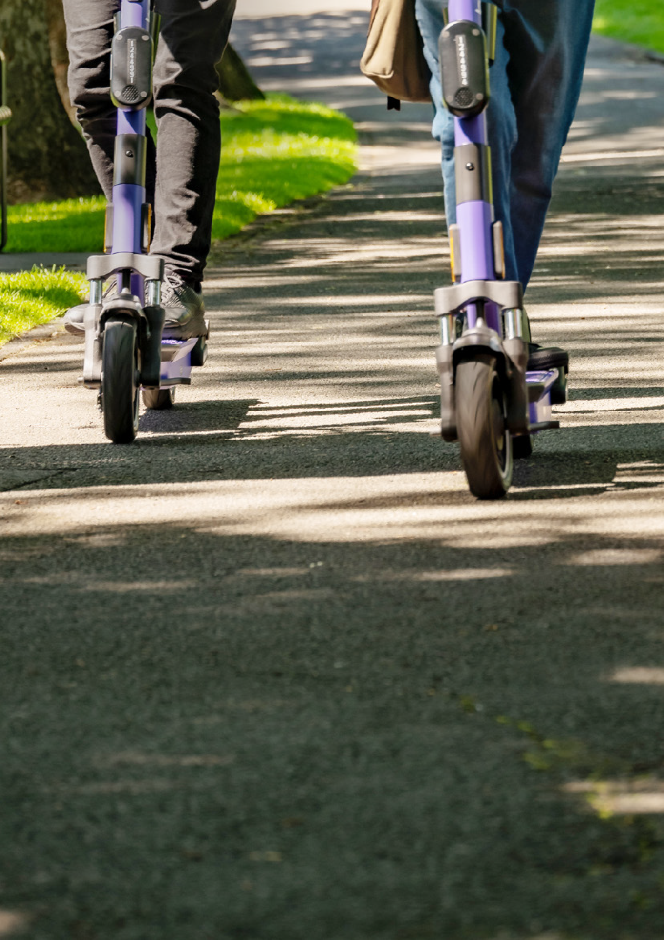
About

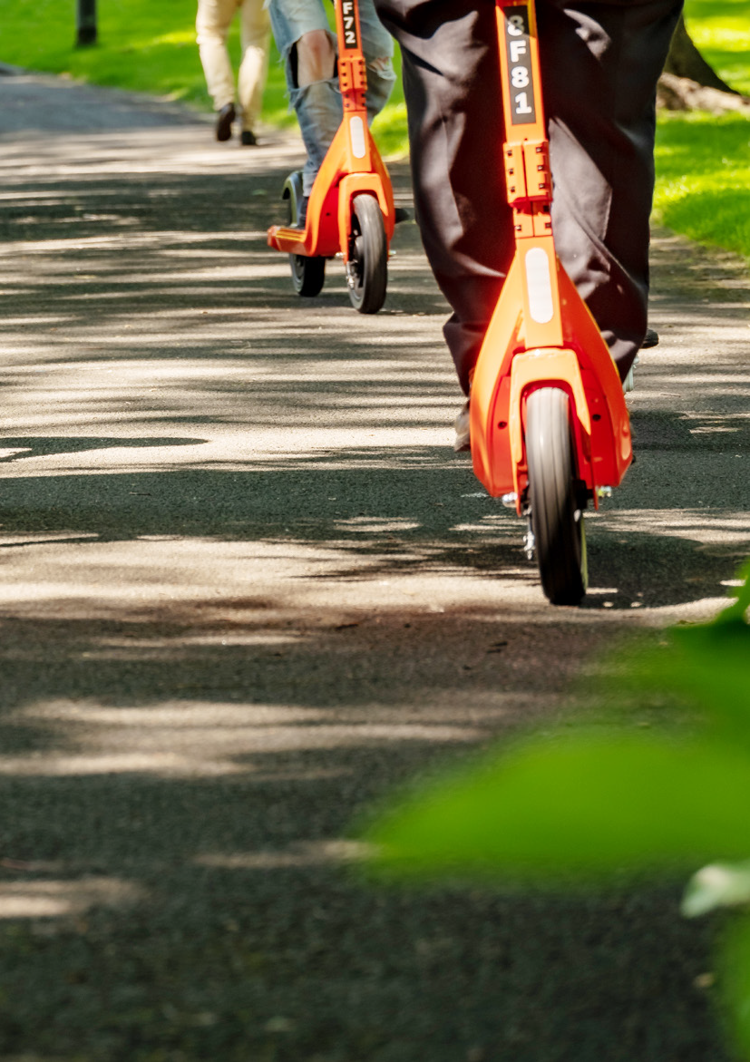
2

About

Aims and objectives
The aim of this report is twofold:
- To evaluate what the trial has found in relation to the impact of e-scooter technology in Hobart.
- To evaluate what the trial has found in relation to the role the City of Hobart can play in managing the impact of personal mobility devices such as e-scooters.
This evaluation is designed to inform the City of Hobart in its decision making on hire-and-ride micromobility services in Hobart.
Method and approach
In order to evaluate the impact of e-scooter technology in Hobart, this report explores the extent to which the use of e-scooters has met the strategic objectives of the City of Hobart as expressed in the Capital City Strategic Plan, Sustainable Hobart Action Plan, and Connected Hobart Action Plan, defined by the following questions:
- Do e-scooters improve connectivity within Hobart?
- Do e-scooters increase the sustainability of transport within Hobart?
- What are the safety impacts of e-scooters?
To evaluate what the trial has found in relation to the role Council can play in managing the growth of personal mobility devices, the report draws upon:
- the legislative settings
- the City’s experience engaging and working with the providers and other stakeholders to manage issues that have arisen during the trial.

City of Hobart Micromobility (e-scooter) Trial 10

Evidence sources
To answer these questions, the evaluation draws upon:

Usage data from the device providers
As part of the e-scooter trial, both providers (Beam and Neuron) were required to make their usage data available to the City of Hobart.

Incident data
Both e-scooter providers supply incident data to the City of Hobart. The City of Hobart also has regular contact with Tasmania Police to discuss e-scooters.

Accident comparison data
In mid-2022, the City of Hobart commissioned an external transport consultant to compile accident comparison data with other forms of transport (car, bicycle, pedestrian).
Also Royal Hobart Hospital (RHH) Emergency Department and Trauma Team published an article in Emergency Medicine Australasia
in October 2022 outlining the burden of
e-scooter injuries during the first six months of the trial.

The survey provided an opportunity for interested community members, including both residents and visitors, to provide feedback on the e-scooter trial, including their use of e-scooters, their reasons for using or not using e-scooters, their support or opposition to the continued use of e-scooters, and their views about improvements to the
e-scooter trial and future transport options for Hobart.
The City of Hobart engaged Metropolis Research, a social research firm based in Melbourne, to evaluate the survey findings.
Metropolis noted that the survey reflects the views of those in the community who were sufficiently engaged in the issues relating to e-scooters to participate and should be read as a poll of interested community members.

Community survey
The e-scooter trial survey was an open- access, self-selection online survey provided on the City of Hobart website from the 04 July to 24 July, 2022 and obtained a large sample of 2,048 respondents. A small number of these respondents came from a randomly approached on-the-street sample.
Evaluation report 11

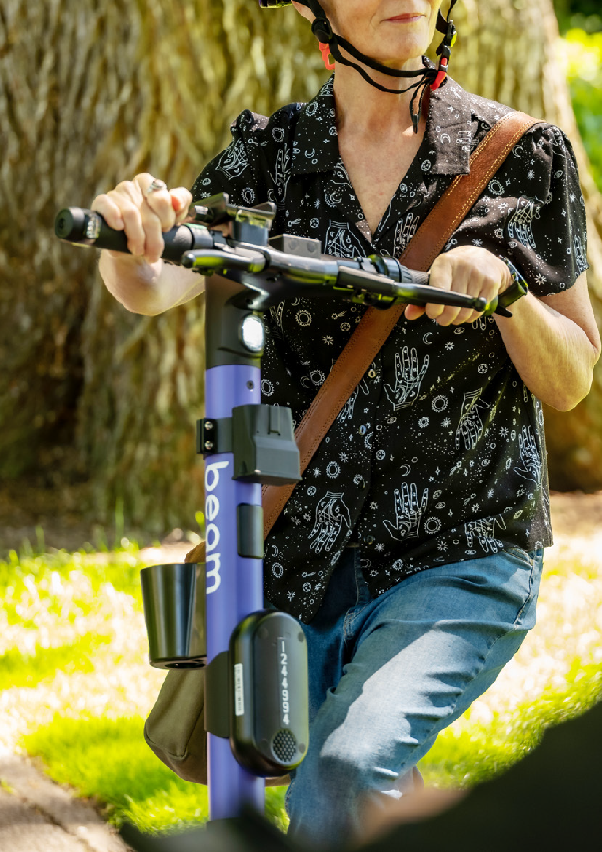
Findings

3

Findings

Rides per month in 2022

92,399

71,684

35,821 52,292

45,220

35,652

33,834

30,065
27,486 26,336 26,367 24,868

Do e-scooters improve connectivity within Hobart?
Over the trial, until January 18, 2023 Hobart has seen the following use of e-scooters.
- Number of rides: 604,516
- Total ride time: 5,077 days
- Distance travelled: 741,185 km
The number of people using e-scooters has fallen steadily over the period of the trial.
The monthly ride totals are as follows, with the tourist population boost of the “Dark Mofo effect” clearly visible in June:

City of Hobart Micromobility (e-scooter) Trial 14

Day of the week
Saturday is the most popular day of the week to ride

119,210

64,477 68242
63,264
59,278
92,682
90,458

Distance
Short trips dominate the ride statistics

326,154

139,615

49,063

21,727

9,564

1,385

0–1k m
1–2km
2–3km
3–4km
4–5km
5km+

Evaluation report 15

Findings (cont’d)

Rides made from 6am to 9am

4290

4581

4890

4947

4989

3070

2763

While the most popular days to ride
e-scooters were Friday, Saturday and Sunday, early morning trips (6am to 9am) were predominantly seen on Monday to Friday, suggesting people were using e-scooters to commute.

City of Hobart Micromobility (e-scooter) Trial 16

Connectivity and accessibility
Connectivity can also be measured by how transport options provide opportunity for people to participate in community life, both socially and economically.
While the usage data doesn’t show who is using e-scooters and for what purpose, the community survey provides valuable insight.
The community survey found that the most common uses for e-scooters were for recreation and fun (64%), getting to and from social gatherings, dining, entertainment (55%), and commuting to and from work or study (41%).*
The survey also provides some valuable insight as to how different cohorts use e-scooters:
- Younger (aged under 26 years): Respondents were more likely than average to use e-scooters for recreation and for connecting to public transport.
- Younger middle-aged adults (aged 46 to 55 years): Respondents were more likely than average to use e-scooters to commute to work or study and to run errands.
- Older middle-aged adults (aged 56 to 65 years): Respondents were more likely than average to use e-scooters to attend appointments.
- Gender: Male respondents were more likely than female respondents to use e-scooters to commute to work or study, to run errands, and to attend appointments.
- Disability status: Respondents with a disability were more likely than other respondents to use e-scooters to attend appointments.
Case study: Blueline Laundry
On 22 October 2022 the City of Hobart organised for Beam and Neuron to provide e-scooter safety and awareness training to staff at Blueline Laundry, a Hobart business that provides employment opportunities
to people of all abilities. Blueline CEO Mike Sylvester reported to the City that the introduction of e-scooters as a low-cost transport alternative had positively impacted his staff’s access to employment, punctuality rates and general well-being, particularly those suffering transport challenges.

Do e-scooters increase the sustainability of transport within Hobart?
One of the purported impacts of e-scooters is the displacement of short car trips.
Respondents to the community survey who had used an e-scooter in Hobart were asked: “If an e-scooter had not been available, what mode of transport would you have used?”
Almost two-thirds (66.1%) of respondents who had used an e-scooter reported that if an e-scooter had not been available, they would have used a car instead. A slightly smaller proportion (62.1%) reported that they would have walked if an e-scooter had not been available.

* Respondents were able to choose multiple options within the community survey

Evaluation report 17

Findings (cont’d)

It is noted that frequent (i.e., at least once a week) users of e-scooters were more than twice as likely to be replacing driving to their destination compared to occasional users
of e-scooters. These results clearly show that the use of e-scooters does appear to have a meaningful impact on the use of non- sustainable transport modes particularly
for frequent users of e-scooters. Frequent users of e-scooters were most likely to be replacing a car-based trip, either as a driver (48.8%), taxi or ride-share (25.7%), or car as a passenger (12.9%).

Traffic and congestion
Personal mobility devices, such as e-scooters, have the potential to alleviate traffic in cities, especially for short trips for inner suburb residents and first/last mile journeys.
The effect of this is not only to reduce CO2 emissions, but to reduce congestion and parking demand for those who choose to travel by private car.
Research conducted prior to the trial using City of Hobart parking data combined with external data sources, showed that in some congested suburbs, more than 20% of car journeys that ended with a parking event were intra-suburban trips, many of which were under 1 km. Another 40% were from an adjoining suburb. This left only 40% of private car trips made from more than one suburb away. In the absence of other modes, the
short trips are most conveniently made by car. But when micromobility modes are available, it becomes far more efficient to make the

trip in a low-emissions, easily parked vehicle. Reducing a small percentage of trips into a suburb makes a significant difference to the quality of traffic and availability of parking within that zone.

Emissions reduction
There have been approximately 741,185 km of e-scooter travel during the trial.
These trips are estimated to have offset 378,004 km of fossil fuel-based travel, according to Hobart survey data.
This data suggests that approximately 51% of e-scooter rides replaced fossil-fuel car travel, equating to 66 tonnes of CO2 averted as a result of the e-scooter trial.
Similar externally sourced surveys on
mode-shift data in Tasmania have found the following:
- Beam data – 51% of users claim they use a scooter to displace car trips
- Neuron data – 57% of users claim they use a scooter to displace car trips
- Independent EMRS survey data – 79% of users claim they use a scooter to displace car trips.

City of Hobart Micromobility (e-scooter) Trial 18

What are the safety impacts of e-scooters?
Like all cities where e-scooters have been trialled, local conditions must be used to set the trial conditions to create a balance between individual rider responsibility, rule enforcement, and public safety.
Hobart has experienced low incident rates in its e-scooter trial compared with other cities around Australia (see below table for comparison with Queensland and the Australian Capital Territory), as well as a
reduction in incidents since the trial began, suggesting that skill level, education, enforcement and familiarity have improved safety outcomes over time. There have unfortunately been 6 e-scooter deaths in Australia since 2018. Five of these have been riders of privately owned e-scooters.
During the trial, the City has seen:
- 1 minor incident (requiring some form of first aid or medical intervention) per 22,000 rides and
- 1 serious incident (defined as an incident requiring a stay in hospital longer than
24 hours) per 140,000 rides.
25 of the 29 reported incidents were minor incidents (requiring some form of first aid or medical intervention) while 4 have been
serious incidents, meaning incidents requiring 24 hours or more in hospital (this is the same metric used to assess car accident statistics).

Reported incidents

 | Hire and ride e-scooters
Fatal | 0
Serious | 4
Minor / first aid | 25
Property Damage Only | 39

Accident comparison to other modes
In mid-2022, the City of Hobart commissioned an external transport consultant to compile the accident comparison data shown
in the table below. At the time this was commissioned there had been 10 mild and 4 serious injuries reported as a result of
e-scooter incidents in Tasmania. Serious injuries are defined as having required an overnight stay in hospital. No catastrophic injuries had been reported at the time of commissioning, and none have been reported since.

Evaluation report 19

Findings (cont’d)

Hospitalisations by Mode*

E-scooter (2021)
M | S | C | M | S | C | M | S | C | M | S | C
10 | 4 | 0 | ? | 404 | 38 | ? | 189 | 0 | ? | 59 | 5
(2022) | (2022) | (2022) |  | (2018) | (2020) |  | (2018) | (2020) |  | (2018) | (2020)
[1.84] | [0.74] | [0] |  | [74.73] | [7.03] |  | [34.96] | [0] |  | [10.91] | [0.92]
 |  |  |  | 6,102 | 134 | 2.143 13 |  |  |  | 832 | 29
 |  |  |  | (2018) | (2020) | (2018) (2020) |  |  |  | (2018) | (2020)
 |  |  |  | [91.14] | [2.00] | [32.01] [0.19] |  |  |  | [12.42] | [0.43]
 |  |  | 590 | 4,103 | 184 | 125 | 2,308 | 14 | 110 | 924 | 48
 |  |  | (2020) | (2020) | (2020) | (2020) | (2020) | (2020) | (2020) | (2020) | (2020)
 |  |  | [7.23] | [50.26] | [2.25] | [1.35] | [28.27] | [0.17] | [1.35] | [11.32] | [0.59]
 | 529 | 1 |  | 5,285 | 183 |  | 367 | 7 |  | 317 | 34
 | (2021) | (2021) |  | (2020) | (2020) |  | (2020) | (2020) |  | (2020) | (2020)
 | [10.22] | [0.02] |  | [102.14] | [3.54] |  | [7.09] | [0.14] |  | [6.13] | [0.66]
 |  |  |  | 1,484 | 111 |  | 667 | 5 |  | 188 | 11
 |  |  |  | (2018) | (2020) |  | (2018) | (2020) |  | (2018) | (2020)
 |  |  |  | [27.87] | [2.09] |  | [12.53] | [0.09] |  | [3.53] | [0.21]
 |  |  |  | 1,193 | 64 |  | 496 | 2 |  | 148 | 8
 |  |  |  | (2018) | (2020) |  | (2018) | (2020) |  | (2018) | (2020)
 |  |  |  | [67.43] | [3.62] |  | [28.03] | [0.11] |  | [8.36] | [0.45]
 |  |  |  | 488 | 23 |  | 71 | 1 |  | 73 | 3
 |  |  |  | (2018) | (2020) |  | (2018) | (2020) |  | (2018) | (2020)
 |  |  |  | [198.37] | [9.35] |  | [28.86] | [0.41] |  | [29.67] | [1.22]
38 |  |  |  | 287 | 7 |  | 217 | 0 |  | 24 | 0
(10 wks) |  |  |  | (2018) | (2020) |  | (2018) | (2020) |  | (2018) | (2020)
[45.80] |  |  |  | [66.57] | [1.62] |  | [50.34] | [0] |  | [5.57] | [0]

Car
(driver or passenger)
Bicycle Pedestrian

TAS
(year)
[*]

VIC
(Year)
[*]

NSW
(Year)
[*]

QLD
(Year)
[*]

WA
(Year)
[*]

SA
(Year)
[*]

NT
(Year)
[*]

ACT
(Year)
[*]

*Crash by Severity – Injuries (Individuals Involved)(18/12/2022 – 31/8/2022)

Legend
M – Mild injury (bumps, knocks and grazes) S – Severe injury (4 or more days in hospital)
C – Catastrophic injury (permanent injury, disability or death) [*] Rate per 100,000 state population (2020)
Sources
- Department of Infrastructure, Transport, Regional Development and Communications, 2021, Road Trauma Australia Statistical Summary, Australian Government, https://www.bitre.gov.au/sites/default/files/ documents/road_trauma_australia_2020_statistical_summary.pdf
- Transport for NSW, 2022, NSW Centre for Road Safety, Interactive crash
statistics, NSW Government, https://roadsafety.transport.nsw.gov.au/ statistics/interactivecrashstats/serious-injuries.html?tabinj=2
- Queensland Transport and Main Roads, 2020, Queensland Road Crash
Weekly Report, QLD Government, https://www.publications.qld. gov.au/ckan-publications-attachments-prod/resources/1028e58d- c73c-430d-9f71-d876b6db17fa/weekly-report-2020. pdf?ETag=%22eb722a87951401455d57fe154422d4de%22

City of Hobart Micromobility (e-scooter) Trial 20

Royal Hobart Hospital (RHH) Emergency Department and Trauma Team published an article in Emergency Medicine Australasia in October 2022 entitled ‘The rise and falls of electronic scooters: A Tasmanian perspective on electronic scooter injuries’.
The article outlined that electronic scooter (e-scooter) popularity has soared since the introduction of e-scooter renting systems in the USA in 2017. E-scooters can be located using an app, ridden to their destination and deposited without a specific docking terminal. Many e-scooter users see them
as environmentally friendly, cost-effective and convenient. However, other community members believe e-scooter riders pose a risk to pedestrians, cyclists and drivers, as well as to themselves. Recognising concerns about e-scooters, but also their potential utility for the local community, the article explores the burden of injury from e-scooters presenting to Tasmania’s major trauma centre during the first 6 months of the Hobart e-scooter trial.
All Emergency Department presentations and inter-hospital transfers were recorded from 11 December 2021 to 26 June 2022, coinciding with the first 6 months of the City of Hobart’s e-scooter trial, to identify e-scooter- associated injury. Of 135 presentations
to accident and emergency, 31 (20%) were admitted to the hospital. None were
admitted to intensive care, and injuries were overwhelmingly minor. It was not recorded if these presentations were from hire-and-ride services or private e-scooter accidents. It is also important to note that private e-scooters are not speed controlled at the legal speeds of 25km on roads and 15km on footpaths, as are hire-and-ride devices.
The Royal Hobart Hospital’s 6-month peer- reviewed report concluded that the Hobart e-scooter trial has been associated with few major injuries.

Evaluation report 21

Findings (cont’d)

What the trial has found in relation to the role the City of Hobart can play in managing the growth of personal mobility devices such as e-scooters

With private e-scooters becoming a popular, low-emission transport alternative, a controlled rollout of hire-and-ride e-scooters gave the City an opportunity to:
- oversee aspects of the use of these devices,
- electronically prevent or restrict usage in certain zones, and
- collect data to assist in managing the future of transport in Hobart.
By running this trial, the City has had an opportunity to manage the impact
e-scooters have on residents, businesses and infrastructure by maintaining a proactive
engagement with a small number of permitted operators of e-scooter services in Hobart, managing their activities under a formal arrangement, and preserving a level of oversight over their activities.
Specific changes to trial conditions in response to community safety feedback have included the following:

City of Hobart Micromobility (e-scooter) Trial 22

- removing e-scooters’ ability to travel through certain areas, including some private car parks, sports fields and aged care zones;
- removing e-scooter parking from specific areas, for instance from outside a blind services facility;
- working to assist guide dog training so that the animals can learn to recognise e-scooters;
- creating learn-to-ride sessions that ran throughout the year for different community groups;
- requiring safety messaging on scooters and in apps;
- restricting the use of e-scooters in Salamanca on weekend nights;
- creating slow zones in zones with high pedestrian numbers;
- mandating that fines, suspensions and bans must be issued by the operators;
- running safety campaigns; and
- creating physical parking bays.
In the absence of a formal arrangement with the hire-and-ride e-scooter operators
whose devices can be controlled by location- sensitive software (geofencing), it is unlikley that the City of Hobart would have been able to implement and enforce such changes.

The Connected Hobart Smart City Action Plan and the Capital City Strategic Plan identify data-informed decision making as critical components of Hobart’s future success. In this regard, the trial has provided a valuable opportunity to further the City’s ambition in harnessing data to drive strategic outcomes for Hobart.
The e-scooter operators have collected a vast number of data points and have shared these with the City to provide a data-rich mobility service. This has allowed the City to build a reporting system which aggregates trip numbers, locations, ride times and distances. This increasingly allows the City to estimate CO2 saved, provide heat maps and other metrics on routes, time of use, type of use, safety, as well as providing data on key routes and destinations, for better precinct and transport planning. The system is web- enabled and aggregates data from different operator APIs, in a form that can provide indexed, raw data for fast analysis to other of the City’s GIS and digital twin systems.
This data about urban movement trends and footpath status assists with future
infrastructure, audits, and governance and has highlighted the growing need for shared paths and protected bike lanes to support future city transport trends.

Evaluation report 23

Conclusion

4

Conclusion

Based on the available evidence, the e-scooter trial has met the City of Hobart’s objectives outlined in the Capital City Strategic Plan, Sustainable Hobart Action Plan and the Connected Hobart Smart City Action Plan through enabling new, innovative, and sustainable ways for people to move about the city. As with all transport modes, there
are safety and amenity issues that require management.
Importantly, any decision about hire-and-ride e-scooters in Hobart will not impact the growing popularity of private e-scooters.
The City will still need to be actively engaged, manage risks, respond to community concerns, and support active transport infrastructure transformation with or without hire-and-ride services. Engaging with hire- and-ride operators provides opportunity for the City of Hobart to realise the opportunities of micromobility, while maintaining leverage to influence the future of new mobility services and modes.

City of Hobart Micromobility (e-scooter) Trial 26

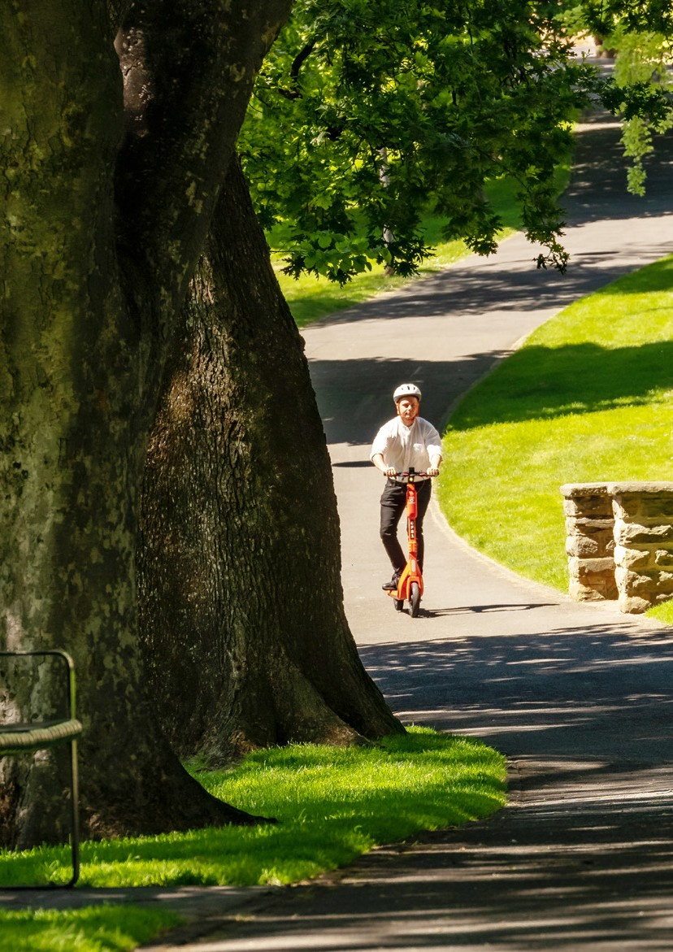

Evaluation report 27

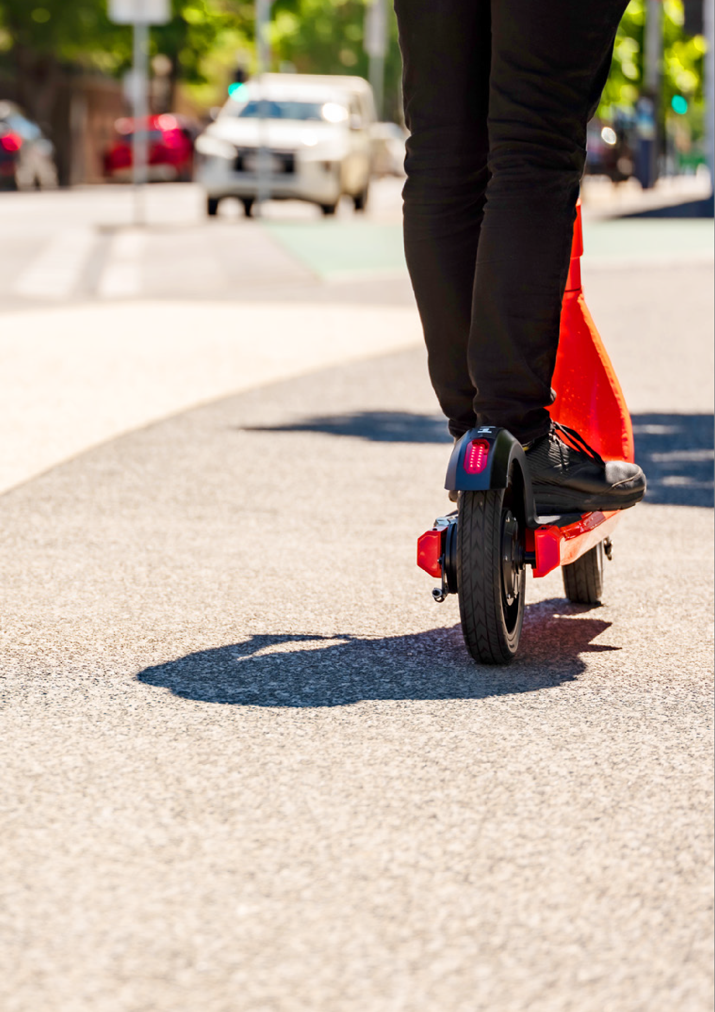
City of Hobart e-scooter trial information: www.hobartcity.com.au/e-scooters

