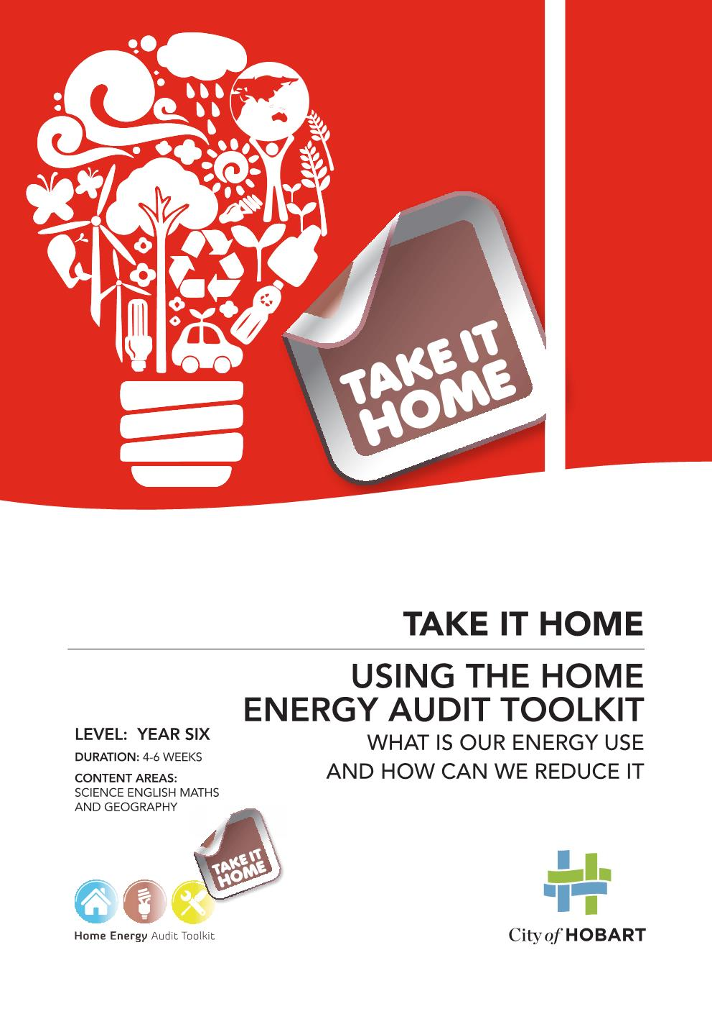
Using the Home Energy Audit Toolkit
This resource is designed to help Year Six students develop an awareness of energy consumption, energy efficiency and energy costs in the school and home. The activities are based around the Home Energy Audit Toolkit which comes with equipment to help students undertake detective activities and look for clues on how energy is being wasted. Students are encouraged to plan and take action in practical ways to save energy.
Investigating energy in your home and school is easy and can help you identify:
- Where energy is being wasted
- What you can do to save money
- Ways to make your home and school warmer
- How to reduce your environmental impact

Energy use in a typical Tasmania home | Energy use in a typical Tasmanian school
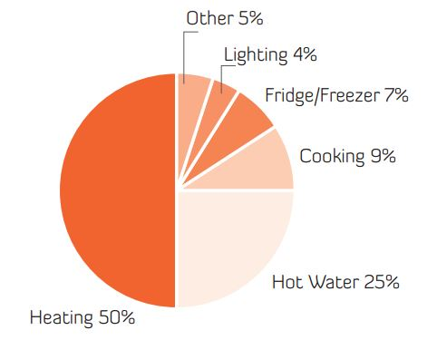 | 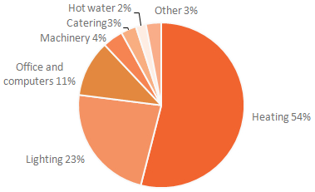

Energy use in

Contents
Investigating electricity use 3
Activity 1. Where does electricity go? 4
Activity 2. CSI: super snoops: energy wasters 5
Activity 3. How to use the Home Energy Audit Toolkit equipment 7
Activity 4. How much does it cost to run your classroom appliances? 8
Activity 5. What appliances use electricity in your home? 8
Activity 6. Making popcorn and boiling water 11
Activity 7. Investigating light globes 12
Investigating hot water 14
Activity 8. CSI: shower sleuths 14
Activity 9. Saving on hot water heating 16
Investigating building orientation 17
Activity 10. Finding direction 17
Investigating warmth 18
Activity 11. Measuring temperature 18
Activity 12. Some Like it Hot! 19
Activity 13. Measuring the effectiveness of insulation 20
Activity 14. CSI: draught detectives 22
Activity 15. Draw your house and show where the heat can escape. 23

Investigating electricity use
We buy energy, eat energy, waste energy, lose energy, and we use energy to ride a bike, run skip and play. When an object is moving it has energy. When you run you have energy. There are different types of energy (thermal, mechanical, electrical, etc.) which enable a person, an animal or a physical system to change and make something happen.
Have a look at this TED Ed guide to the energy of the Earth
There are many sources of energy. In 2015 around 55% of Tasmania’s energy came from burning fossil fuels (like petrol used in our vehicles and coal and natural gas used in our industries). Around 40% of our energy came from electricity, principally generated using the power of hydro and wind (but also from mainland coal-fired power stations and local diesel generators).
In Tasmania, big industry uses 43% of our total energy and 24% is used to power our motor vehicles. Around 13% is used in our homes, mainly in the form of electricity. One third of the energy we use in homes in Tasmania comes from wood used for heating.
Most of the energy used in our homes and schools in Tasmania is electrical energy, so this is the focus of the following activities.
Electrical energy is the flow of charged particles called electrons or ions. When electrons are flowing through a wire or through hundreds of metres of air (lightning) it is because they are being "pushed" or forced by an electrical field. This field is caused by a difference in electrical charge. A force is exerted on the electrons and they move. Work is done on the charged particles. A force is pushing them through a distance.
Our energy use has a direct effect on our environment. The more energy we use, the more we rely on fossil fuels and the more changes we will see in our weather, our climate and life on earth. That’s why it is important to find ways to use less energy, wherever possible.

What do lightning, a flashlight, an alarm clock battery, and a toaster have in common? And what about a computer, a car battery, a light bulb, the shock you feel when you shuffle across a carpet and then touch something? They are all powered by a form of energy called electricity (electrical energy).

- Where does electricity go?
Trying to get a handle on how electricity is used in your home or school can be difficult because electricity bills are not itemised like a phone bill or shopping receipt. In order to understand electricity use, you will need to investigate how and where you use it.
Use this survey to think about electricity in your home and school
There are no right or wrong answers, rather ideas to start some discussion.
What do you think? | Yes | No | Don’t know
My family is energy conscious.
I turn lights off when I leave a room.
Electrical items on stand-by use no electricity.
I spend more than ten minutes under the shower.
I put on a jumper when I get cold.
I can tell where north is.
I can read a thermometer.
Space heating uses half the energy costs in a Tasmanian home.
Heating water uses a quarter of the energy costs in an average Tasmanian home.
Lighting uses a quarter of the energy costs in an average Tasmanian school.
We could save energy in our school.
Discussion questions
- In your own words describe energy
- Why should we save energy?
- How can you save energy in your home and school?

- CSI: super snoops: energy wasters
Energy efficiency can be improved with good energy habits. The first stage to saving energy
is to have a walk around your school or home and snoop for wasted energy, bad habits and opportunities to change.

Energy detective walk  - Key questions to get started | Yes | Some | No | Don’t Know | Opportunity (rate 1-5)
Do the windows have double glazing or energy-saving glass?
Are the windows well sealed with no gaps or draughts around them?
Are outside doors self-closing?
Do people leave doors open?
Are inside doors self-closing?
Does each room have its own heating thermostat?
Is the heating set to an energy efficient temp (23 degrees or less)?
Are low-energy light bulbs and fluorescent tubes used?
Are printers, faxes and photocopiers put in energy saving mode when not in use?
Are lights and electrical items turned off when not being used?
Is external lighting turned on only at night?
Do external lights have sensors?
Are fans and air filters regularly cleaned?
Can you find energy wasted in unoccupied rooms?
Are lights off when there is enough daylight?
Is there renewable energy (such as photovoltaic solar panels)?
Are there solar hot water panels?
Are windows and doors closed to keep the heat in?
Are appliances turned off at the power point when not in use?
Are lights and electrical items turned off when not in use?
Is there insulation around hot water pipes?
Is the hot water set to the correct temp (not more than 60 degrees)?
Is the fridge set at between 5 and 7 degrees Celsius?
Is the freezer set at between –7 and -18 degrees Celsius?
Are there draught stoppers under door gaps?
Is there insulation in the ceiling?
Is the ceiling insulation even? Test with the radiometer.
Are there low flow shower heads?
Are there curtains to keep in the heat?
Are the places where heat can escape blocked off, (like chimneys)?
Is the jug or kettle only filled with just enough water for the purpose?
Do people wear warm clothes in winter?
Other snoopy ideas

Discussion questions
- What opportunities are there to reduce energy use?
- How could you change the behaviour of others in your home or school to reduce
energy use?
- How to use the Home Energy Audit Toolkit equipment
Examine a piece of equipment from the Home Energy Audit Toolkit (HEAT) to decide what its function is. What do you think this piece of equipment is used for? Brainstorm how it could help you make your home more energy efficient?

Name of object:
What are the possible uses? | How could this help increase energy efficiency in the home?

Discussion questions
- Schools and homes have different uses of energy, what are some examples?
- Some changes are easier to make than others, these are called the low hanging fruit. What are some examples of low hanging fruit in your home and school?

- How much does it cost to run your classroom appliances?
Monitor equipment in your classroom to understand how much it is used each day
(on average). Use the Power-Mate to find out the amount of watts used per hour for each item, including items that use standby mode. Often equipment on standby will be warm to the touch, have an indicator light (such as a camera charger) or a clock (such as a microwave or TV). The most standby electricity in offices and schools is used by computers (49%) and monitors (28%).

Name of appliance | Number of items | Watts used per hour  (active) | Hours of use per day | Watts used per hour (standby) | Hours on standby per day | Total watts per day  =(AxBxC) +  (AxDxE) | Total kilowatts  per day  =F/1000  (Remember 1000 watts = 1 kilowatt) | Cost  per day (at $0.27 per kW)  =0.27 x G
 | A | B | C | D | E | F | G
E.g. Computer | 10 | 200 watts | 6 | 20 | 18 | 12,000 +3600 | 15.6 | $4.21
Total costs of classroom appliances over a year (dollars/kWh) |  |  |  |  |  |  |  | =

Discussion questions
- What have you found out about electricity use in your classroom or school?
- Discuss how you can reduce classroom electricity use throughout the school.
- Does your school take steps to reduce standby electricity? List examples.

- What appliances use electricity in your home?
List appliances used in your family home and estimate about how much money these would cost to run. Using the Powermate, test out your hypotheses and see whether your ideas about your home’s electricity consumption were on the money or not.

Appliance | Estimated cost per year | Watts used per hour | Kilowatts used per hour  (A/1000) | Estimated hours used per day (if in minutes divide by 60) | Total kW used per day  (BxC) | Cost  per day (at $0.27dollars per kW)  (Dx0.27cents) | Cost per year  (Ex365)
 |  | A | B | C | D | E
Toaster 4 slice (used 10 minutes each day) |  | 1629 | 1.629 | 0.167hrs  (10mins) | 0.272kW | $0.07 (7 cents) | $25.75
Toaster 2 slice |  | 817
Spotlight (used 2 hours per day) |  | 176 |  | 2 hrs | 0.352 | $0.10 (10 cents) | $36.50
Hotplate
Kettle
Coffee maker (standby) |  | 0.45
Fan
Rice cooker

When you have finished, check your findings with the numbers in the table below
Appliance | Watts used per hour  (Remember 1000 watts = 1 kilowatt) | Cost per hour  27 cents for each kilowatt used each hour (27 cents per 1 Kwh) | Watts used per hour for standby power | Annual standby costs (=$0.27 x kW x hours per year)
Blow Heater | 2000 watts (2kW) | 54 cents per hour
Computer | 200 watts (0.2kW) | 5.4 cents per hour | 5 watts (0.005kW) | =$0.27 x 0.005 x 6570 (i.e. 18 hours x 365 days)/1000 = $8.87
Electric blanket | 200 watts (0.2kW) | 5.4 cents per hour
Hair dryer | 2000 watts (2kW) | 54 cents per hour
Laptop | 20 watts (0.02kW) | 0.5 cents per hour
Iron | 1000 watts (1kW) | 27 cents per hour
Kettle | 2000 watts (2kW) | 54 cents per hour
Fridge | 100 watts (0.1kW) | 2.7 cents per hour
Clock radio | 4 watts (0.004kW) | 0.1 cents | 4 watts | =$0.27 x 0.004 x 8760 (i.e. 24 hours x 365 days)/1000 = $ 9.46
Energy saver light globe | 10 watts (0.01kW) | 0.27 cents per hour
Television big | 200 watts (0.2 kW) | 5.4 cents per hour | 10 watts | $15
Microwave |  |  | 4 watts | $6
Mobile phone charger |  |  | 1 watts | $2
Printer |  |  | 8 watts | $11

Choose 3 appliances and energy efficiency opportunities to examine more closely.
Name of appliance | Possible inefficiency | Possible solutions
e.g. spare fridge in garage/clock radio | Left on 24/7 | Turn off at power point when not being used
Discussion questions
- Are there ways you could improve efficiency and save your family money?
- What is the most expensive appliance?
- What uses most power over the year?
- What surprises you?
- How much would a blow heater cost if you used it for one hour per day for
150 days in the year?
- How much would the clock radio and computer cost running 24/7?

- Making popcorn and boiling water
Which costs more to operate, a microwave or a popcorn maker? Calculate the cost of making popcorn in a popcorn machine or in a microwave. Use the Powermate to compare the costs of cooking a tablespoon of popcorn (in a paper bag in microwave) for 2 minutes, compared to a popcorn maker.
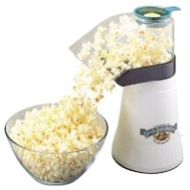 | Watts | Cost per hour | Cost per minute (divide by 60) | Total time to cook popcorn | Total cost
Microwave |  |  |  | 2 minutes
Popcorn maker
Compare costs of boiling a cup of water with a kettle or in a microwave.
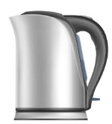 | Watts | Cost per hour | Cost per minute (divide by 60) | Total time to boil a cup of water (minutes) | Total cost to boil a cup
Microwave
Popcorn maker
Discussion questions
- Which costs less and what is the difference in the cost?
- Are there other ways to boil water and cook popcorn? Could these be cheaper and use less energy?
- Investigating light globes
Lights have been transformed again and again and the humble domestic light bulb is becoming more and more energy efficient. Tasmanian schools use 23% of their energy on lighting, so investment in more efficient lighting can have a very quick payback time.
- Gather a number of light globes and learn how to correctly identify them. Which is which?
- Plug the light globes into a desk lamp and using the Power Mate from the Home Energy Audit Toolkit, test and record the wattage output in the table below.
- Compare different wattage globes in a darkened room and record what you notice about the colour and brightness of each one.
- Use a light meter to measure the light of each globe (if your school has one).
- Compare this with candle power.
Incandescent light globe bulb | Compact fluorescent light | Halogen lights | LED globes
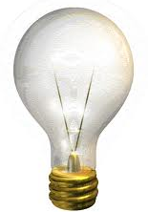 | 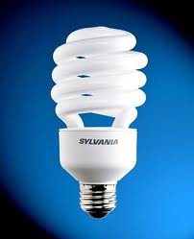 | 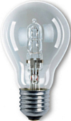 | 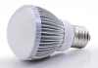

Light Globe Conversion Table
Watts are the measure of power, lumens are the intensity of light.
Incandescent bulbs | Compact fluorescent light (CFL) | Halogen lamp | Light output in lumens (lm) light intensity
25 watts | 5-7 watts | 18 watts | 220 lm
40 watts | 7-8 watts | 28 watts | 420 lm
60 watts | 11-12 watts | 42 watts | 720 lm
100 watts | 13-18 watts | 52 watts | 930 lm

Globes | Watts | Lumens= brightness  Comments
Incandescent
CFL
Halogen
LED

Discussion question
- Making changes to the home (e.g. installing efficient light globes, sensors, etc.) is a
great way to reduce energy use, but it is even more effective when combined with behavior change. Can you think of strategies that would help you have better habits into the long-term? Some people remind themselves why they are doing it (‘don’t melt the penguins’
ice unless you have to’). Other people form habits (‘check the lights are off every time you leave a room’).

Investigating hot water
Did you know that about 35% of the energy used in the average home is for heating water? Reducing your hot water use can save your family money, decrease greenhouse gas emissions and ease the pressure on our river systems and their animals and plants.
More than half our hot water use is in the bathroom, a third in the laundry and the remainder in the kitchen. One of the best ways to reduce energy bills is to reduce hot water use by installing water efficient showerheads and taps. You can also take shorter showers, use cold water to wash clothes and rinse dishes and use mixer taps in the cold water position when hot water is not required.
- CSI: shower sleuths
The long, hot shower is the biggest user of hot water. Use the stopwatch and a bucket to calculate how many litres of water your shower uses in a minute then calculate what each person’s shower costs.
Who | Time in shower | Number of showers per week | Total minutes per week  A x B= | Litres per minute of hot water use (use bucket and timer) | Total litres used per week  C x D = | Electricity used  (0.045kW* x litres)  0.045 x E | Cost per week (15 cents per kW)  15 x F =
 | A | B | C | D | E | F | G
Dad | 5 mins | 7 showers | 35 minutes | 20 litres per minute | 700 litres | 31.5 kW  (700L x 0.045kW) | $4.73  (15c x 3.15kW)
Mum | 10 | 7 | 70 mins | 18L | 1260 litres | 56.7 kW  (1260 x 0.045kW) | $8.51  (15c x 5.67kW)
Total costs per week
Total cost per year
* 0.045kW is the amount of electricity used (in an average home) to deliver you a nice hot litre of shower water.
** on average it costs 15c for each kW used to heat hot water
Hot water is a third of weekly household energy use (or around 63kW of a total weekly average of 196kW)
Discussion questions
- Who takes the longest and shortest showers?
- Would a timer help your family have shorter showers?
- What does it cost your family to shower each year? The average is about $146 per person each year. How does your family compare?
- A standard showerhead uses about 15 to 25 litres of water per minute. A three-star rated water efficient showerhead uses as little as 6 or 7 litres per minute. Calculate how much less water you would use with a water efficient shower head and how much money your family could save.

- Saving on hot water heating
There are a number of easy ways to reduce your hot water bills. Go home and check these five things around your home.
- The cylinder cabinet
The HEAT radiometer can be used to measure the surface temperature of the HW cylinder. Compare this to a nearby surface. Most HW cylinders are 1 to 2 degrees warmer than their surroundings. This shows they are constantly losing heat.
Is the cylinder outside in the cold? yes no
Outside or in, is it insulated? yes no
Much heat loss can be saved by wrapping the tank with extra insulation
– especially older cylinders.
Warning: Don’t cover the pressure relief valve.
- The water temperature
What temperature is your hot water supply? .......................................... degrees Celsius
Place a thermometer under the tap. What is the temperature? ……… degrees Celsius
If it is well above 60C, then turn down the thermostat (generally on the side of the cylinder).
Warning: Don’t drop it below 55 degrees Celsius as harmful bacteria can build up.
- The shower
Do you have an AAA-rated shower head? yes no
A standard showerhead uses about 15 to 25 litres of water per minute. A three star rated water efficient showerhead uses as little as 6 or 7 litres per minute. AAA shower heads will give you a satisfying shower at more than half the energy and water costs.
- The taps
Are any leaking? yes no
Discussion questions
- List some more ideas to save on hot water heating.
- Some people say that insulating your hot water pipes will not be effective at reducing
energy use. What are your thoughts on this?

Investigating building orientation
Buildings facing north capture free heat in winter. A passive solar building will have larger windows facing north so that the walls and the floors can collect and store solar energy. Small windows in the south will help reduce heat loss.
- Finding direction
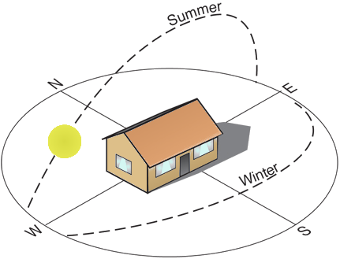
Draw your house and show north. Is your house oriented to collect and store solar energy?
Finding north
On a sunny day hold an analogue watch in your palm so that the 12 is lined up with the sun. North will be half way between the hour hand and the sun. If you have a digital watch draw a clock-face on the ground with the 12 pointing toward the sun. Draw a line half way between the hour hand and the sun. This will point to north.
Check with the compass from the HEAT kit. The red arrow will point to the north.
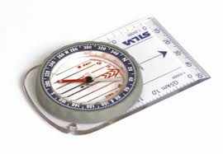
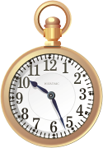
Discussion questions
- Which direction is your school and home oriented towards?
- Could the buildings have been designed better to capture the warmth of the sun?
- Do architects and builders need to consider anything else besides maximizing sun exposure (consider smart Boards, classroom temperatures, gutter width, placement of bathrooms versus living rooms)?

Investigating warmth
Heating is the largest energy user in the average Tasmanian home, so it is important to find ways to reduce your reliance on heating. The first thing to do is to remember to put on a jumper before turning on a heater. Then, only heat the areas you are in by shutting doors. The next step is to stop the heat escaping at night. Ensure your windows are covered with heavy curtains or blinds which seal at the top and bottom and seal draughts around windows, doors and vents.
- Measuring temperature
Record the temperature in the room using a thermometer or radiometer.
Remember: A thermometer should be left in one place for several minutes out of direct sunlight.
WARNING: A laser gun can cause permanent eye damage if shone in someone’s eyes. Ensure students are aware of the dangers of this piece of equipment and commit to its sensible use.
Date | Time | Room | Temp at floor height | Temp at head height | Temp at ceiling height
Discussion questions
- Where are the coolest and warmest areas in the room?
- Can you think of ways to make the room warmer in winter?
- Could the room have been designed better to keep in the warmth?

- Some Like it Hot!
Do you like it hot? Do you like it cool? What is your ideal room temperature? Different people have temperature preferences. Some students will wear shorts in winter, while others will shiver in the next desk.
Ask your family or students in the class if they feel the cold. Record their responses to the room temperature at different times of the day, for example, when people come into school in the morning or after a break. Put a tick in each box as people give their responses.
Date | Time | Outside Temperature 0 C | Inside Temperature 0 C | Too cold? | Too hot? | Just right?
 |  | 15 | 26 | √ | √ √ √√ | √ √ √√√√ √ √
Discussion questions
- What do the results tell you?
- Is the temperature the same in different areas of the room?
- Are there warmer or cooler rooms in the school or house?
- How can different people feel different comfort levels in the same temperature?
- Measuring the effectiveness of insulation
Insulation is anything that helps reduce the transfer of heat. Marine mammals have a thick insulating layer of blubber, sheep have a wooly coat, our Earth has greenhouse gases and our homes have ceiling bats.
Finding out how effective different materials are at keeping in heat can be important for understanding energy efficiency. Using the infrared radiometer, go on a trip around the school or your house and check to see where heat is escaping through the ceiling, floors and walls. Point to the surface, pull the trigger and the temperature will show on the screen.
The infrared radiometer measures the surface temperature of whatever it is pointing at (not shiny surfaces). This can be useful for finding poorly insulated spots on walls, ceilings, floors, hot water cylinders and fridges. Typically, the biggest loss of heat from a building occurs through the ceiling (up to 35%), floors (up to 15%) and walls (up to 30%).
Testing insulation materials
Materials:
- Insulating materials – such as clothing- (cotton, wool and synthetic), newspaper, foam, etc.
- House insulation material – wool, pink batts, fibreglass (handle with gloves)
- Jars with lids: all the same size, on a tray
- A large jug of hot water from the tap
- Thermometers
Method:
- List all the items to be tested.
- Wrap each of the jars in one of the insulating materials. Leave one jar uncovered.
- Record the temperature of the hot water in the jug and then fill each jar.
- Put lids on the jars. Leave for 60 minutes.
- Remove the insulating material and measure the temperature of the water in each jar.
- Which materials kept the water closest to the original temperature?
- Experiment with different lengths of time and thicknesses of insulation. How long does it take for all the jars to reach room temperature? Compare this with a thermos.

Insulation Experiment Results
Insulation type | Temperature of water | 60 minutes later
Discussion questions
- What do these results tell you?
- What material makes the best insulation for houses and for people? Investigate insulation and R factors. The R factor is a measure of how well the material resists the flow of heat through it. http://www.yourhome.gov.au/passive-design/insulation
- CSI: draught detectives
Air ‘leakage’ can increase heating costs in Tasmania by more than 20% and make your home uncomfortable. By sealing off draughts, heat loss can be reduced in winter.
Locating heat loss - outside
In this thermal imaging photograph, you can see where heat is escaping from a house (red=high heat loss, yellow green=medium heat loss, blue = low heat loss). On a cold night, walk around the outside of your house and use the infrared radiometer to indentify where heat is escaping.
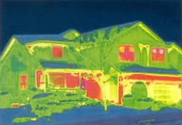
Tick the box when you find heat loss:
where pipes come out of walls
where wiring comes out of walls
out the chimneys
around doors
around windows
entrances to under the house
cracks and holes in the mortar
other

Locating heat loss - inside
Use an incense stick (watch the smoke drift) or your damp hand to locate any leaks around your home. This is best done on a windy day. If you are having difficulty locating leaks, close all exterior doors, windows, and fireplace flues, then turn on any exhaust fans (usually in the kitchen and bathroom) – then use the incense stick.

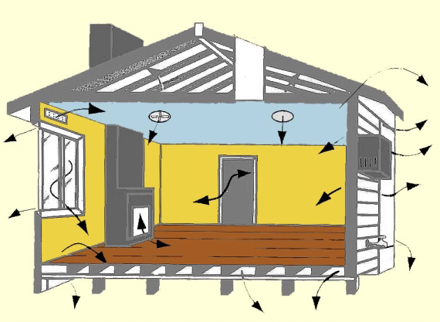
Tick the box when you find leaks:
through air vents
between and around windows
between walls and ceilings
around doors
up the chimney
where pipes come out of walls
between walls or floors
between floorboards
around windows

- Draw your house and show where the heat can escape.

Identify problems and actions that could make a difference.
Problem | Fix it
Gap under back door | Attach door seal
Different temperatures in ceiling | Smooth out insulation
Heat escaping up unused fireplace | Seal ( for example, with a piece of foam) in fireplace when not being used
Discussion questions
- Which rooms are warmest and coolest?
- Where is heating being lost in these rooms?

