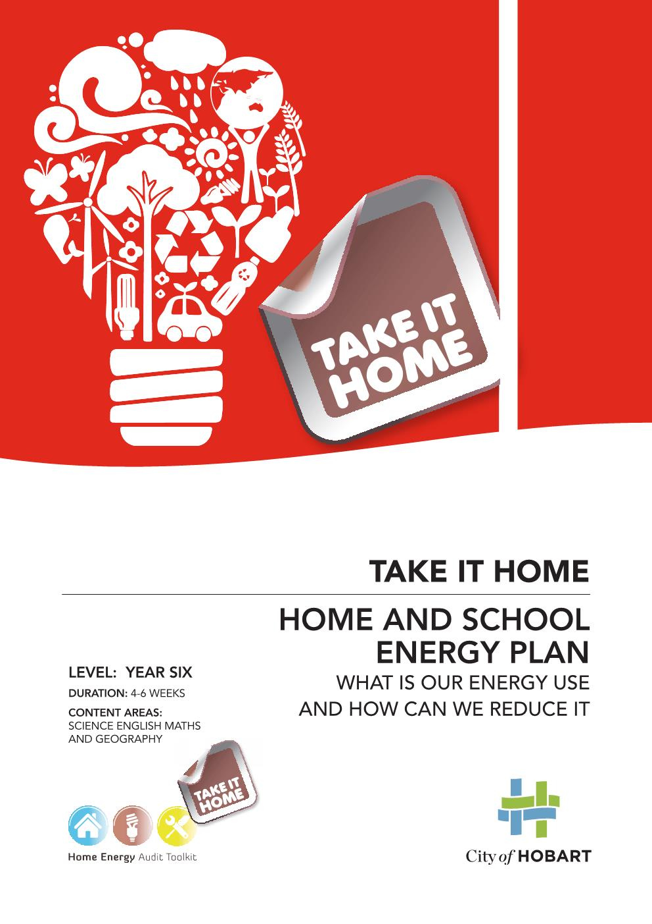
Auditing your home and school
This resource is designed to help Year Six students develop an awareness of energy consumption, energy efficiency and energy costs in the school and home. The activities are based around the Home Energy Audit Toolkit which comes with equipment to help students undertake detective activities and look for clues on how energy is being wasted. Students are encouraged to plan and take action in practical ways to save energy.
Investigating energy in your home and school
is easy and can help you identify:
- where energy is being wasted
- what you can do to save money
- ways to make your home and school warmer
- how to reduce your environmental impact

Energy use in a typical Tasmania home | Energy use in a typical Tasmanian school
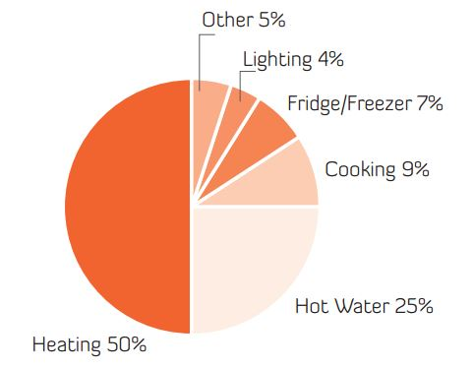 | 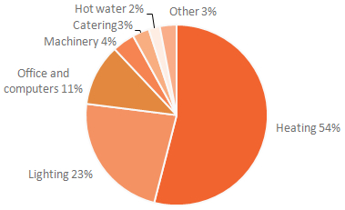

Contents
Investigating electricity use 4
Activity 1. Understanding an electricity meter 5
Activity 2. Understanding an electricity bill 7
Home energy use survey 10
Activity 3. Home energy survey 10
Activity 4. House energy rating 11
Activity 5. Make a home energy plan 13
Activity 6. Make a draught stopper 14
School energy plan 15
Activity 7. Investigate energy consumption 15
Activity 8. Developing an Energy Conservation Plan 18
Understanding climate change 19
Activity 9. Climate change survey 20
Activity 10. The Science of climate Change 21
Activity 11. Make a climate pledge 22

Investigating electricity use
We buy energy, eat energy, waste energy, lose energy, and we use energy to ride a bike, run skip and play. When an object is moving it has energy. When you run you have energy. There are different types of energy (thermal, mechanical, electrical, etc.) which enable a person, an animal or a physical system to change and make something happen.
Have a look at this TED Ed guide to the energy of the Earth
There are many sources of energy. In 2015 around 55% of Tasmania’s energy came from burning fossil fuels (like petrol used in our vehicles and coal and natural gas used in our industries). Around 40% of our energy came from electricity, principally generated using the power of hydro and wind (but also from mainland coal-fired power stations and local diesel generators).
In Tasmania, big industry uses 43% of our total energy and 24% is used to power our motor vehicles. Around 13% is used in our homes, mainly in the form of electricity. One third of the energy we use in homes in Tasmania comes from wood used for heating.
Most of the energy used in our homes and schools in Tasmania is electrical energy, so this is the focus of the following activities.
Electrical energy is the flow of charged particles called electrons or ions. When electrons are flowing through a wire or through hundreds of metres of air (lightning) it is because they are being "pushed" or forced by an electrical field. This field is caused by a difference in electrical charge. A force is exerted on the electrons and they move. Work is done on the charged particles. A force is pushing them through a distance.
Our energy use has a direct effect on our environment. The more energy we use, the more we rely on fossil fuels and the more changes we will see in our weather, our climate and life on earth. That’s why it is important to find ways to use less energy, wherever possible.
Auditing your energy use can help highlight where it is being used and where changes can be made.

What do lightning, a flashlight, an alarm clock battery, and a toaster have in common? And what about a computer, a car battery, a light bulb, the shock you feel when you shuffle across a carpet and then touch something? They are all powered by a form of energy called electricity (electrical energy).

- Understanding an electricity meter
Trying to get a handle on how electricity is used in your home or school can be difficult because electricity bills are not itemised like a phone bill or shopping receipt. In order to understand electricity use, you will need to learn how to read an electricity meter and electricity bills.
At home read your meter. There are different meters and the instructions below should help you. More information about reading your meter can be found on the Aurora Energy Website.
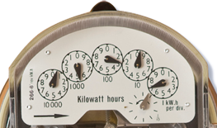 | Dial meter
Stand directly in front of your meter so you can tell the exact position of the pointer of each dial.
Read the dial on the right first (ignore the dial underneath)
Look at the two numbers the pointer is between and record the lowest number. (If the pointer is between 9 and 0, record 9.)
Do the same with each meter, reading right to left.
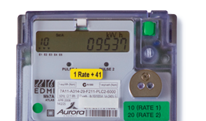 | Digital meter
Read the number that appears on the display for each electricity tariff that is attached to that meter.
For the most common digital or dual rate meters, the display will automatically cycle through the different tariffs. Including:
10 - Element 1 (Tariff 22 or 31 – light and power)
20 - Element 2 (Tariff 41, 42, 61 or 62 if applicable – Hydro-Heat, hot water and/or Off-Peak)
To ensure you know which tariff each element refers to, check the back of your bill which shows the different costs for each tariff. E.g. hydro heat, residential light and power.
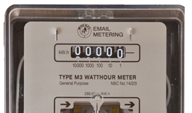 | Odometer meter
Another kind of analogue electricity meter reads like an odometer in your car. Numbers are read from left to right.
The meter has five white digits that show the kilowatt hours of electricity that have been used.

Compare meter readings over 24 hours:
- Record the kilowatt hours on your meter reading at a set time. A kilowatt hour (kWh) is a measure of how much energy you’re using.
- Record the meter reading the next day at the same time and calculate how many kilowatt hours (kWh) you have used in a day.

Reading one
Date |  | Time
Tariff 31 light and power |  | Units (kWh)
Tariff 42 hydro heat |  | Units (kWh)
 |  | Total units (kWh)

Reading two
Date |  | Time
Tariff 31 light and power |  | Units (kWh)
Tariff 42 hydro heat |  | Units (kWh)
 |  | Total units (kWh)

Electricity use in one day
Work out how much electricity your home used over one day for both hydro heat and light and power.
Reading Two minus (-) Reading One = Total kilowatt hours you have used in a day
Light and power = | Units (kWh)
Hydro heat = | Units (kWh)

Once you can read your own meter, your family can easily predict future electricity costs using the Aurora Energy online calculator.

- Understanding an electricity bill
Understanding your electricity bill can help you understand how your household uses electricity.
Below is an example of a quarterly bill (a quarter of a year or 91 days) from the Aurora website.
The first image shows the comparison provided with each bill. It shows how this household compares with different sized households.
- Page 1 is a summary with the account number, amount due and pay by date.
- Page 2 shows the detailed breakdown of charges.
Fixed Charges consist of meter reading, billing costs, part of the meter capital cost and some of the costs of maintaining and connecting to the electricity distribution system. This is the same cost no matter how much electricity you use.
Energy Charge is the charge for each unit of electricity (kWh) that covers the cost of generating the electricity and some of the transmission and distribution costs.

Using the example bill, investigate and discuss the following:
- Look at the name and mailing address. Is this a true name and address? Why choose this name? What other names could be used?
- What are the different rates for hot water (hydro heat) and light and power?
- The bill is calculated quarterly but is not always exactly 91 days. What is the number of days for this bill?
- Find the average daily consumption at the bottom left hand side of the bill:
- What is the difference in energy use this year with last year?
- What is the average daily cost?
- Bills differ with the seasons. What season is this bill? How do you think it would differ from other seasons?
- Discuss this bill with a partner. Compare this bill with your school bill or a bill from home.
- Compare different bills in winter and summer.

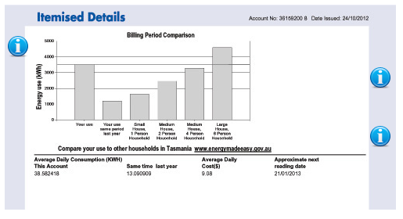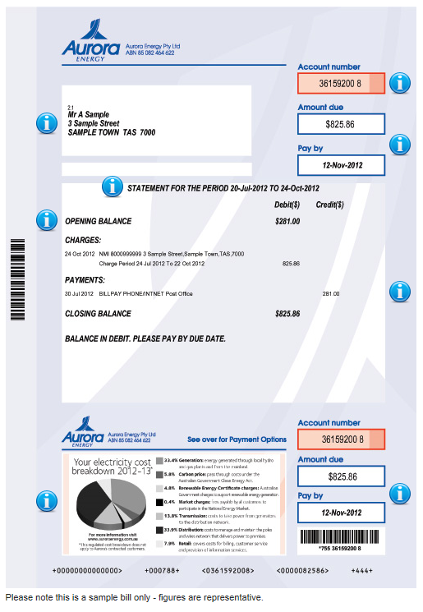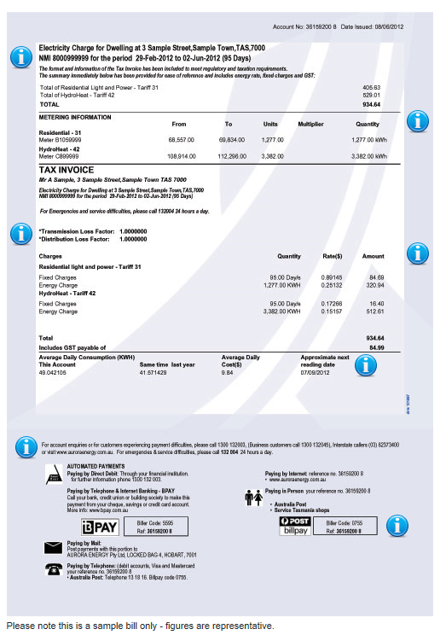
Home energy use survey
The average Australian home uses about 20 kWh of electricity per day or 10,000 kilowatt hours (kWh) per year. This costs approximately $2,500 per year and is used for space heating (50%), heating water (25%), cooking (9%), refrigeration (7%), appliances (5%) and lighting (4%).
- Home energy survey
Take a moment to think about energy use in your family then discuss and investigate in groups how the following features could help reduce or increase energy use.
Size of house
Number of family members: adults
Number of family members: children
Spa bath
Clothes dryer
Clothes line
Spare fridge
Water tanks
Thick lined curtains
Pelmets
Hot water cylinder un-insulated or outside
Type of heating: electricity
Type of heating: gas
Type of heating: wood heater
Type of heating: hydro heat
Solar hot water
Photovoltaic panels
Does your family try to save energy? | Yes a bit we don’t worry
Do you think your electricity bills  are too high? | Yes No No idea

- House energy rating
The National House Energy Star Ratings were introduced for Australian houses in 2003. The star rating of a house depends on:
- the construction of its roof, walls, windows and floor including materials that store heat such as concrete and the thickness of the insulation;
- the layout of the home such as rooms which can be closed off (for e.g. a long shaped house allowing light into all rooms);
- the orientation of windows and angled to the sun's path;
- how well these suit the local climate.

What the stars mean
Zero stars means the building shell does practically nothing to reduce the discomfort of hot or cold weather. A tin shed will rate zero stars. There is no insulation and no thermal mass to hold the heat.
Three stars usually means there is no insulation in the walls or floors of a building, and minimal insulation in the ceiling and single glazed aluminum windows. An example would be a typical un-renovated freestanding brick veneer home.
Five stars means that a building can store energy from the sun and needs minimum levels of heating and cooling to be comfortable. Houses with a 5 star rating should be comfortable to live in and have lower energy bills.
Ten stars usually means a building does not need any artificial cooling or heating. They will have double glazed windows, well insulated walls and floors and be oriented to absorb the sun’s heat which keeps the rooms warm in the evening.

Assess your own home and tick.
The more ticks the better energy rating your house will have.
Windows single glazed
Windows double glazed
Large windows facing north
Walls insulated
Floors wooden
Floors insulated
Floors concrete
Ceilings insulated
What star rating would
you give your house?
Discussion question
- Can you think of other features your home has that help keep the heat in?

- Make a home energy plan
Saving energy at home needs all the family to change habits. Make a time with your family to talk about how you can all save energy. Plan a timetable to record your activities.
Energy Saving Action Checklist
 | Action | Target date | Done
Check stand-by energy rate of every appliance in the home. | Use Powermate  Talk to all family members about reducing stand-by energy by for example turning off appliances at the power point.
Fridge/ freezer | Check correct temperature settings and door seals.
Showers | Check family times
 | Install low-flow shower head.
Hot water cylinder | Check temperature to be set at 60 degrees.  Check all pipes are insulated.
Whole house | Exclude draughts from all entry points.  Get draught stoppers.
Lighting | Change all lighting to low energy options.  Turn lights off when not being used.
Insulation | Check with a radiometer; get an adult to check in the ceiling space.
Some rooms are not used | Close off rooms

- Make a draught stopper
An effective way to keep heat in is to block draughts. Try making a door snake or draught stopper. Invite knitters to come into the classroom to help you get started.
Research the men who knit on Taquile Island, in Peru, South America. Only the men on the island knit and they start when they are eight years old.
Collect knitting needles and wool from your local op shop
You will need:
- 8 ply yarn. Size 4.00 mm (No 8) knitting needles (or similar). Wheat (or similar) grain to fill. Old stockings. A large tapestry needle to stitch up.
Simple draught stopper instructions:
- Cast on 32 stitches in your first colour (call it ‘A’);
- Work 5 rows, knit and purl;
- Change to your second colour (B), Work 4 rows;
- Change to your third colour (C), Work 4 rows;
- Change to your fourth colour (D), Work 4 rows;
- Change to colour A;
- Repeat this sequence until work measures 80 cm long;
- Cast off;
- To complete - Sow seam along length, with insides together;
- Gather one end together with a stocking stitch and pull tightly;
- Secure end tightly. Turn right side out and stuff with a stocking filled with wheat.
For extra decoration you could sew 2 large pompoms to each end of the snake.

Pompom Instructions:
Using strong card cut out 2 circles 10 cm across. Make a 5 cm diameter hole in the centre. Put the 2 circles together. Start winding wool around the cards through the hole. Wind wool evenly around until the centre hole is full. Cut the wool and then slide the tip of the scissors between the two pieces of card and cut the wool at the edges of the circle all the way around. Tie a strong length of wool between the pieces of card and tie it firmly around the middle. Remove the card and fluff up the pom pom.

School energy plan
Through this activity you will collect data about the school’s energy consumption and look at how this can be reduced. Armed with this information you can provide the school with recommendations and actions.
The school’s energy consumption will be affected by a range of factors:
Age of school - Newer schools tend to be better energy performers because they will be better insulated, use solar aspect and use more energy efficient heating and lighting.
Additional facilities - Sports halls and kitchens will lead to an increase in energy consumption.
School size - small schools tend to use more energy per student than larger schools. There are more buildings to heat with less student numbers.
Number of students - An increase in number of students in a school can increase electricity use with more classrooms which have to be lit and heated. Smaller school numbers can mean that some classrooms are not used.

- Investigate energy consumption
Ask office staff to write down the school’s energy use each quarter over the last two years
Billing date | Electricity consumption | Electricity cost
Summer
Autumn
Winter
Spring
Summer
Autumn
Winter
Spring

Investigate heating
Around 54% of the energy used in schools and 50% of energy used in homes is for heating. Allocate a room to each student to do a spot audit.
Investigate | Record your findings
How is the classroom kept warm?
When the heating system comes on and goes off and how this happens, e.g., automatic or manual.
How the temperature changes in the school over the day and how this relates to the heating system.
Any controls in place to manage electricity use?
Comfortable temperature on cold days with a jumper on sitting at a desk?

Investigate appliances
Do several spot audits and estimate the time appliances are on and being used and not used.
Room | Appliances
 | Printers | Computers | Monitors | Other | Notes
Library | 5 (left on for 24 hrs, used for 5 hrs) | 5 | 5 | -
Staff room
Hall
Totals

Investigate lighting
Do a spot check around the school and record how many lights and appliances are left on.
Room | Types of lights
 | Fluorescent | Quartz halogen | CFL | Incandescent | Other | Notes
Library | 5 (left on for 8 hrs, needed for 6)
Staff room
Hall
Totals

Discussion questions
- Did you find many electrical items on but not being used?
- Can you see reasons why people choose to leave them on?
- Why does electricity use dip down in December and January?
- Is this school in a cold place or a warm place?
- Compare different years. How has the electricity use changed over time?
- What can you change?

- Developing an Energy Conservation Plan
Can you think of ways to increase awareness of electricity use in the school to reduce usage and costs? Identify the problems and make an energy saving plan for your school with targets. Consider how you will encourage the whole school to get on board.
Problem | Action | Target | Who will do this? | Possible barriers | When
Lights left on when the room is empty | Organise light monitors, organise reminder signs | reduce wasted electricity | Class monitor
Computers left on over the weekend |  |  | Teacher | Inconvenient
Inefficient light globes |  | No light on when room is empty
High heating costs | Reduce thermostat | Encourage students to wear jumpers |  | Too cold

Discussion question
- Choose one issue associated reducing energy and brainstorm possible actions that could be taken to address this issue at school and at home. Why should this be done? What might the disadvantages be? How would this save energy? How will you take action? What behavior change is required?

Understanding climate change
Climate change is a change in the average pattern of weather over a long period of time. Greenhouse gases, such as carbon dioxide, water vapour and methane, play an important role in determining our climate because they act like an insulating blanket keeping the earth’s surface warm.
Our planet's atmosphere traps energy just like a greenhouse. Energy from the Sun can enter the Earth’s atmosphere, but not all of it can easily find its way out again. The greenhouse effect is useful because trapping some energy keeps the temperatures on our planet mild and suitable for living. Without its atmosphere and the greenhouse effect, the average temperature at the surface of the Earth would be minus 18 degrees Celsius. However, the concentrations of these gases in the atmosphere are directly influenced by human activities and have increased significantly in recent times mainly due to our reliance on energy and resources to power our homes, cars, food supply and lifestyles.
As a result our climate is changing, global average temperatures have increased, sea levels are rising, coastal storms are becoming more frequent, rainfall, drought and bushfire patterns are changing and ecosystems are being affected.
These changes will create challenges for Tasmania, with impacts on our fisheries, agricultural sector, coastal communities, and our biodiversity. Further pressure will arise with people wishing to relocate in response to climate change.
Carbon dioxide is one of the main greenhouse gases. The calculations of the amount of carbon dioxide in the air is based on direct measurements of the atmosphere at Cape Grim, Tasmania, older air extracted from Antarctic snow and from air bubbles trapped in ice cores.

Greenhouse gas emissions for a typical 3 person household

- Climate change survey
The following survey is to find out what you understand about climate change. There is no right or wrong answer to these questions, just ideas for you to think about.

What do you think? | Yes/true | No/false | Don’t now
Climate change is a problem for the environment.
People are causing climate change.
People can do something to reduce climate change.
People need to plan for climate change.
Scientists are not certain of the effects of climate change.
Carbon dioxide is being added to the atmosphere faster than it can be removed by plants or absorbed into the ocean.
Increasing greenhouse gas levels raise the temperature of the earth’s surface.
The main cause of global warming is carbon dioxide mainly from the burning of fossil fuels such as petrol and coal.
Global temperatures have increased over the last century.
Global warming will be good for us in Tasmania.
Air trapped in Antarctic ice cores give scientists clues to the amount of carbon dioxide in the air over the last 2000 years.
There is nothing I can do about climate change.

Discussion question
- What is climate change?
- What are the effects of climate change?
- Investigate what you know about greenhouse gases and climate change - Make a mind map.
- Explain to a partner concepts such as carbon footprint, global warming, greenhouse gases, measuring carbon dioxide and climate change.
- Collect words for a word wall. What questions do you have?
- Calculate your carbon footprint on the WWF Australia website.

- The Science of climate Change
Have individual students read out the statements from the Australian Academy of Science and talk about them. Use scientific information from the Australian Academy of Science website to review your survey responses.

- The average surface temperature of the Earth has increased over the last century.
- Greenhouse gases act like an insulating blanket warming the earth’s surface.
- Greenhouse gas emissions from humans are the main cause of global warming.
- The main greenhouse gas causing this warming is carbon dioxide which comes from the burning of fossil fuels such as petrol and coal.
- Carbon dioxide is being added to the atmosphere faster than it can be removed by plants or absorbed into the ocean.
- Global sea levels have risen by 20 centimetres between 1870 - 2004.
- Ocean temperatures around Australia will be 1 degree warmer in 2030 than in 1910.
- Water vapour accounts for half the present greenhouse effect.
- Air trapped in Antarctic ice cores give scientists clues to the amount of carbon dioxide in the air over the last 2000 years.
- Climate models predict that by 2100 the average global temperature will rise by more than 2 degrees (from 1900).
- Reduction of greenhouse gas emissions could significantly reduce long term warming.

- Make a climate pledge
Take responsibility for good energy habits in your classroom
and at home through a climate pledge:
In my personal life, in my home and my school I hereby make a commitment to take steps to reduce my energy use with good energy habits such as:
- Turning off lights when I am out of the room
- Turning off computer equipment when not being used
- Keeping outside doors closed to keep warm air in winter
- Only heating the rooms I need.
- Turning off heating an hour before school ends
- Turning off computers photocopiers and printers overnight rather than leaving them on standby

- Add your own ideas

Signed ………………………………………………………

